**Company Systems Workflow Mapping**

**Table Of Contents**

|  |  |  |
| --- | --- | --- |
| **Sr. No.** | **Contents** | **Page No.** |
| **1.** | [Introduction](#Introduction) | **6** |
| **2.** | [Acknowledgement](#Acknowledgement) | **7** |
| **3.** | [Abstract](#Abstract) | **8** |
| **4.** | [Keywords](#Keywords) | **9** |
| **5.** | [Presently Available System](#AvailableSystem) | **10** |
| **6.** | [Need of such System](#Need) | **11** |
| **7.** | [Detailed Problem System](#ProblemStatement) | **12** |
| **8.** | [Hardware and Software Requirement](#Requirements) | **13** |
| **9.** | [System Design](#SystemDesign) | **14** |
|  | **9.1 ER Diagram** | **14** |
| **9.2 Use Case Diagram** | **15** |
| **9.3 Class Diagram** | **17** |
| **9.4 Activity Diagram** | **18** |
| **9.5 Data Flow Diagram** | **19** |
| **9.6 Flow Diagram** | **22** |
| **9.7 Sequence Diagram** | **23** |
| **10.** | [Application Preview](#ApplicationPreview) | **24** |
| **11.** | [Salient Features](#Features) | **46** |
| **12.** | [Future Prospect](#Future) | **48** |
| **13.** | [References](#References) | **49** |

1. **Introduction**

In this world of growing technologies everything has been computerized. Most of the daily routine tasks needs to be automated to increase the proficiency in the work. With large number of demands and working opportunities the data size has been increased. Thus, there is a need of a system which can handle the data efficiently. This project simplifies the task to maintain each and every working group of the organization. It stores the data efficiently and makes sure that it is used effectively.

The Company Management System has been developed to override the problems prevailing in the practicing manual system. This software is supported to eliminate and, in some cases, reduce the hardships faced by the organization. Moreover, this system is designed for the particular need of the organization to carry out operations in a smooth and efficient manner.

The application is reduced as much as possible to avoid errors while entering the data. It also provides error while entering invalid data. No formal knowledge is needed for the user to use this system. Thus, by this all it proves its user friendly.

The Company Management System will have certain roles that will perform the Top-Level Management tasks, certain roles for performing Mid-Level Management tasks and Employee role which enhance the integrity of the company. The tasks are assigned and completed in a agile manner.

1. **Acknowledgement**

We take this opportunity in expressing the fact that this project report is the result of incredible amount of encouragement, co-operation and moral support that we have received from our beloved teachers, mentors and colleagues.

We are privileged to present the project report on “Company Systems Workflow Mapping” and to express our deep regards towards those who have offered their valuable time and guidance in our hour of need because when any work is to be completed successfully it should be supported and guided by knowledgeable mentors.

“No one achieves success does so without acknowledging the help of others. The wise and confident acknowledge this help with gratitude.”

~Alfred North Whitehead

1. **Abstract**

There are in numerous of activities which needs to be performed for the smooth flow of the company. Handling these tasks manually would take lot of time and will affect the outcome adversely. “Time is Money”, which brings our Company System into picture. This project helps to reduce the manual tasks, and computerizes the various assets that will boost the company’s progress.

“Company Management is like juggling three balls: time, cost and quality. Company management is like a troupe of circus performers standing in a circle, each juggling three balls and swapping balls from time to time.”

~ G. Reiss

The Project will allow admin to add new employees, managing their work, adding new client projects, assigning work to employees, marking employee attendance, managing Project files & reports, salary management, invoice and receipt generation, etc. which makes the whole organization managed effectively by using a single application.

Every organization, whether big or small, have multiple assets which need to be managed properly in order to achieve maximum profits, therefore we designed exclusive Company Management System that adapt to all the managerial and daily routine requirements. This is designed to assist in strategic planning and will help you ensure that your organization is able to achieve its goals. This system ultimately allows you to better manage resources.

1. **Keywords**

Employee Management System, Training Programs, Hiring System, Evaluation Platform, Employee Assessment System, Project Management System, Client Management System, Finance Structure, Invoice generation, Report generation, Attendance System, Salary System, Responsive Pages, Database Management.

1. **Presently Available System**

A Company not only needs automation but also to maintain the workflow and make reliable updates to maintain the stage as planned. Having a distinctive software helps to boost the enterprise tasks resulting into the growth of the firm. The identification of the needs and implementation of the current and future demands are essential for any organization.

The current system includes bunch of manual tasks which eventually slows down the time period of the firm. Having an automation system will help to do the frequent tasks with much swifter and robustness.

Some of the renowned Company System software are Zoho One, Scoro, StudioCloud, Odoo, BaseCamp, NetSuit, Clarizen, etc. and their common features are:

1. User-Friendly Interface.
2. Mobile Accessibility.
3. Structured Task Planning.
4. Task Scheduling.
5. Task Tracking.
6. Task Communication.
7. Integrated Time Tracking.
8. Collaborative Features.

1. **Need of Such System**

A good change is the one that happens gradually - the business and employees also need some time to adjust to the newly implemented system. The manual system will reduce the efficiency in the communication which can create complication in the updates of the projects. As a result, a responsible firm needs management system to track the activities and improvise them to maximize the profits and to stand against stiff competition in the market.

Benefits of Company System

1. **Enhanced management** - Well-organised and systematised business processes.
2. **Increased employee engagement** - Each member of staff is actively involved in the decision-making processes thanks to an excellent information flow.
3. **Collaboration** - Cross-functional teams working along to achieve specific company goals.
4. **Simplicity** - Things are operating smoothly, easily and efficiently; the system is user-friendly, which makes navigating between different screens seamless and effortless for anyone with access rights.
5. **Costs** - An all-in-one business management solution will save you money that you would otherwise have to pay for each individual piece of software providing various services.
6. **Accessibility** – Allows you to access the parts of the system that you need regardless of time or place and, at the same time, prevents those with no access rights from entering; it simply matches access to responsibilities and ensures that the information stays secure.
7. **Avoiding errors** – With business management software, you only introduce the information once and the system will take care of the rest; this [automation](https://cio-wiki.org/wiki/Business_Management_System_(BMS)" \t "_blank) leaves no room for any error whatsoever.

**7. Detailed Problem Statement**

Whether a large or small organization, it has to manage multiple tasks at the same time. Manually doing all those tasks lacks in efficiency and also takes a lot of time. Managing all the paper work is also a challenging task, so now a days there is a demand of having all the task managed from a single compact workspace that will make an organization easy to coordinate between different departments.

To create a better environment and workspace for each client as well as the employee is vitally important to run the routine cycle of the firm.

Company system offers all the features required by a firm to perform the ongoing tasks and create a convalescent domain. The main aim of the Company System is to keep healthy workplace.

1. **Hardware and Software Requirements**

**Hardware Requirements**

* Processor : Intel i5 5th Generation
* Cores : 4
* Processor Speed : 3.0 GHz
* RAM : 4 Gigabytes
* SSD : 1024 Megabytes
* Speed : 1.10 GHz
* Clock Speed : 2.4 GHz
* Graphics : Intel Iris XE

**Software Requirements**

* Operating System : Windows 11 / Linux
* Application : Xampp, Apache Server
* Tools and utilities : PHP Server, Git Bash
* IDE : VSCode / NVIM / Vi / Sublime
* Front End : HTML, CSS, JS
* Framework : Bootstrap
* JavaScript Libraries : jQuery UI, jQuery Migrate, Data-Tables.

1. **System Design**
   1. **ER Diagram**

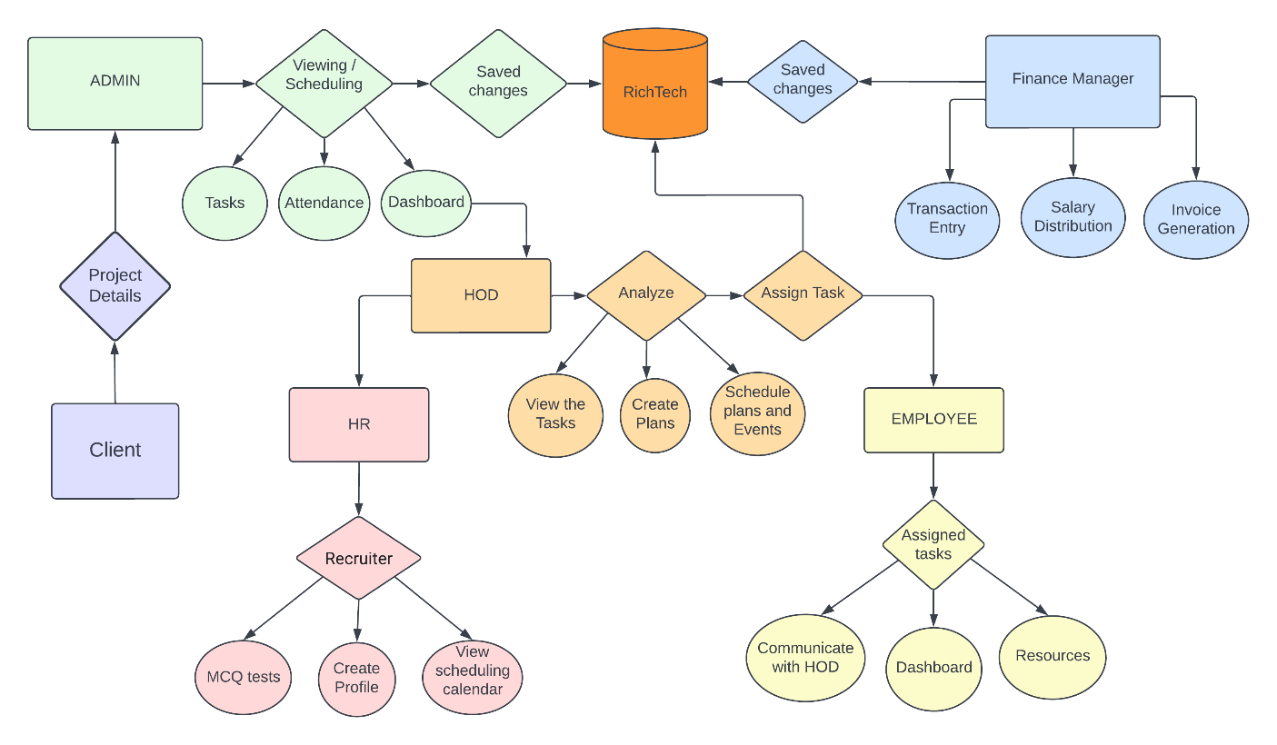

* 1. **Use Case Diagram**

**9.2.1 Employee**

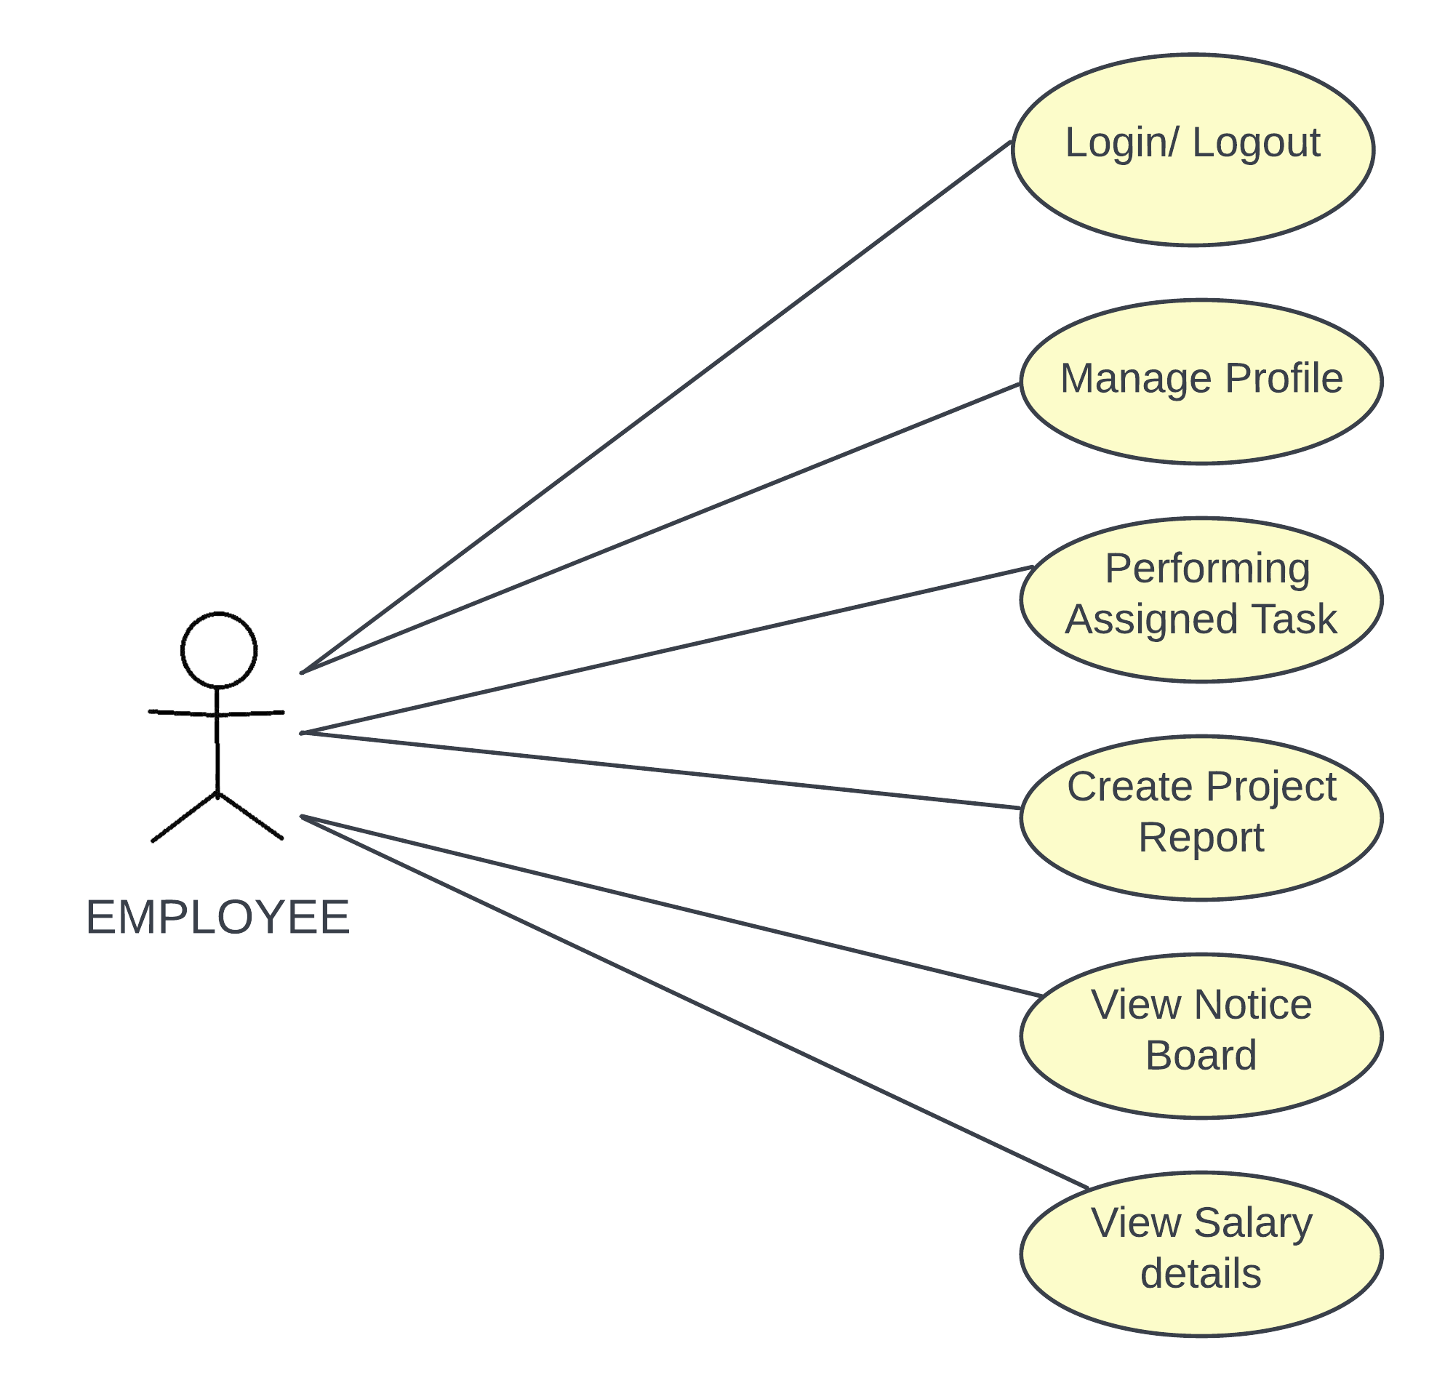

* + 1. **H.O.D. and H.R.**

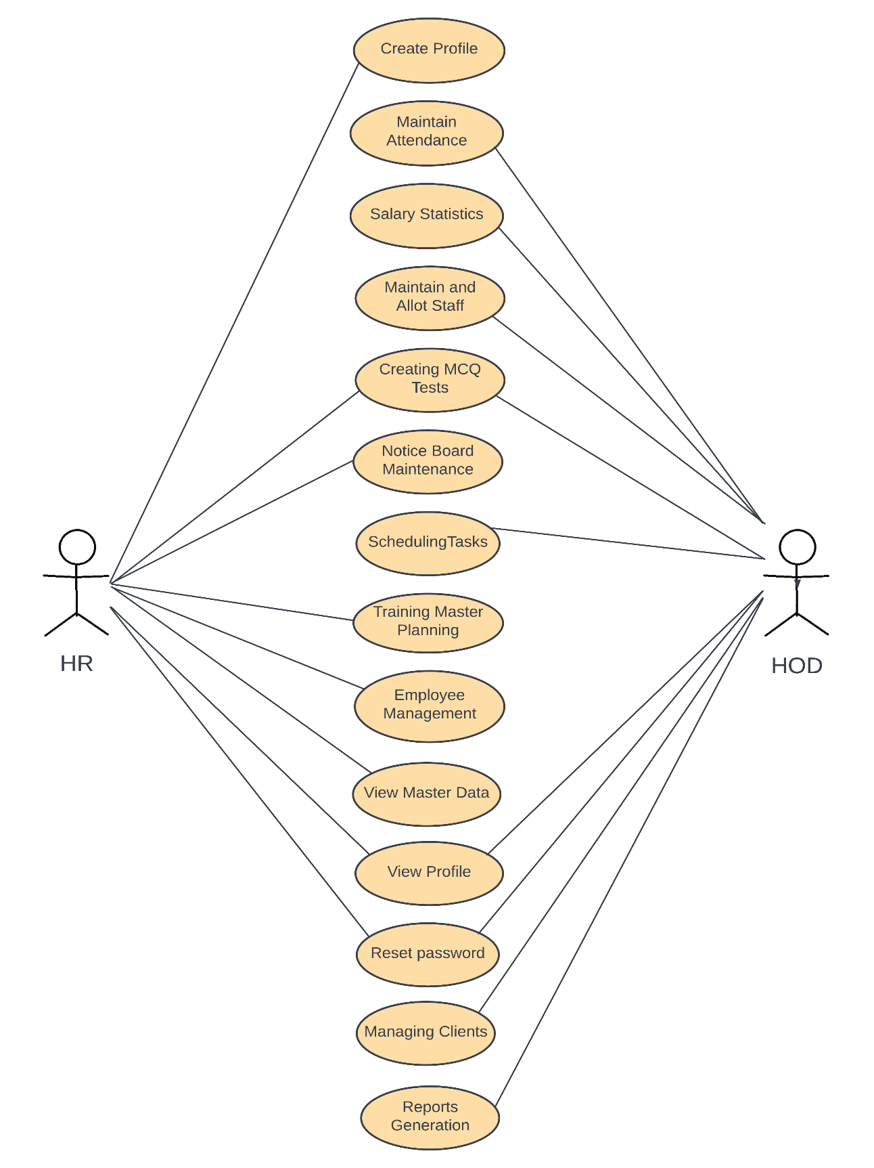

* 1. **Class Diagram**

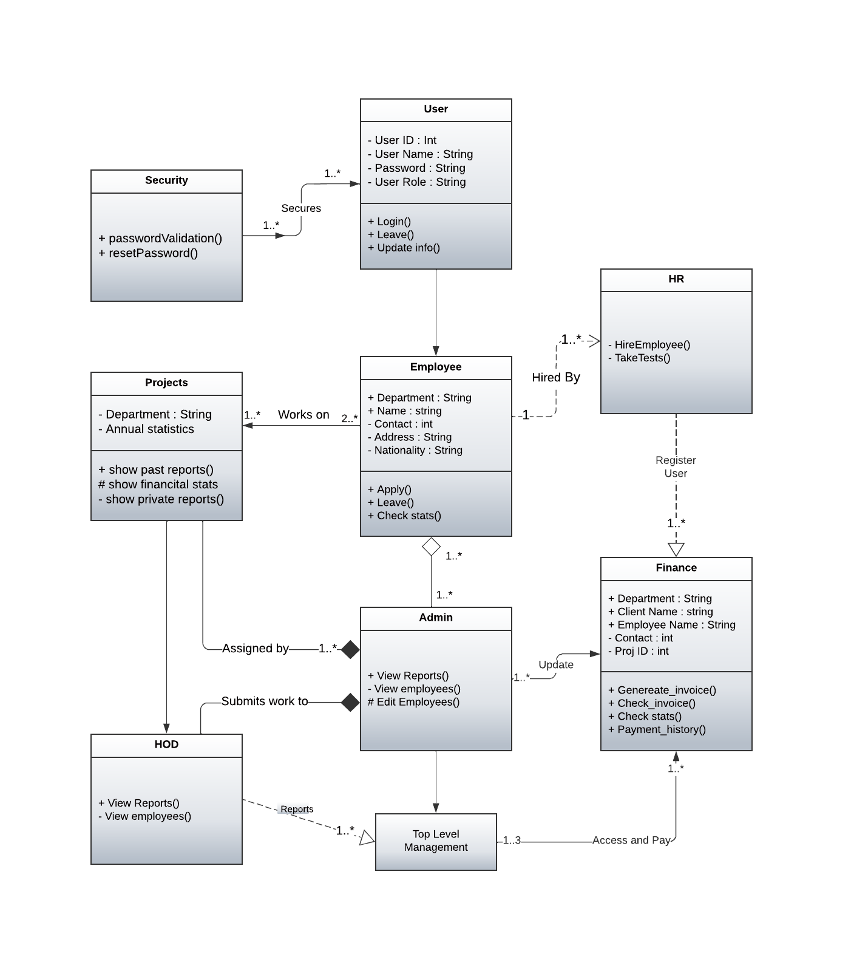

* 1. **Activity Diagram**

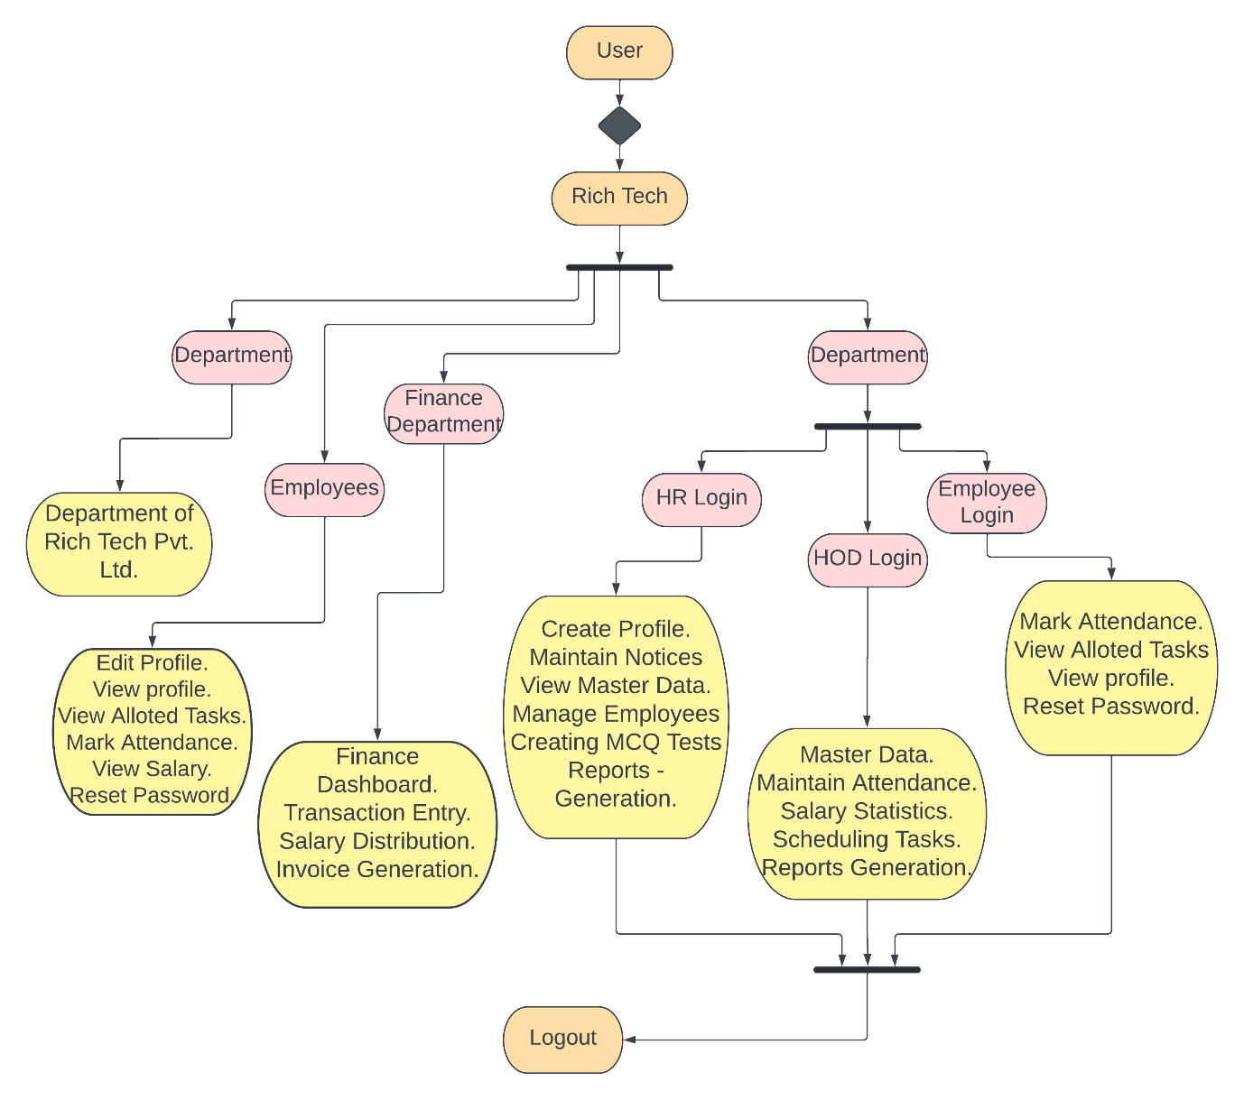

* 1. **Data Flow Diagram**

**9.5.1 DFD Level 0**

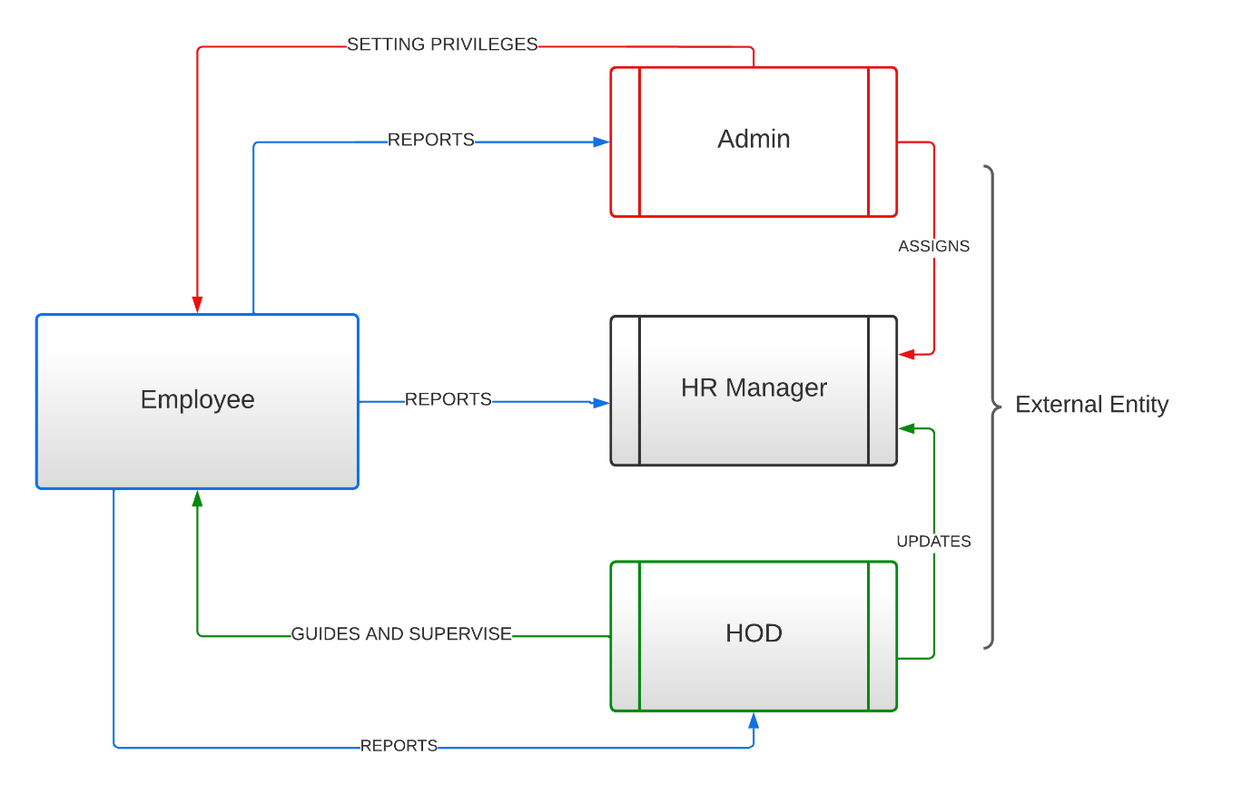

* + 1. **DFD Level 1**

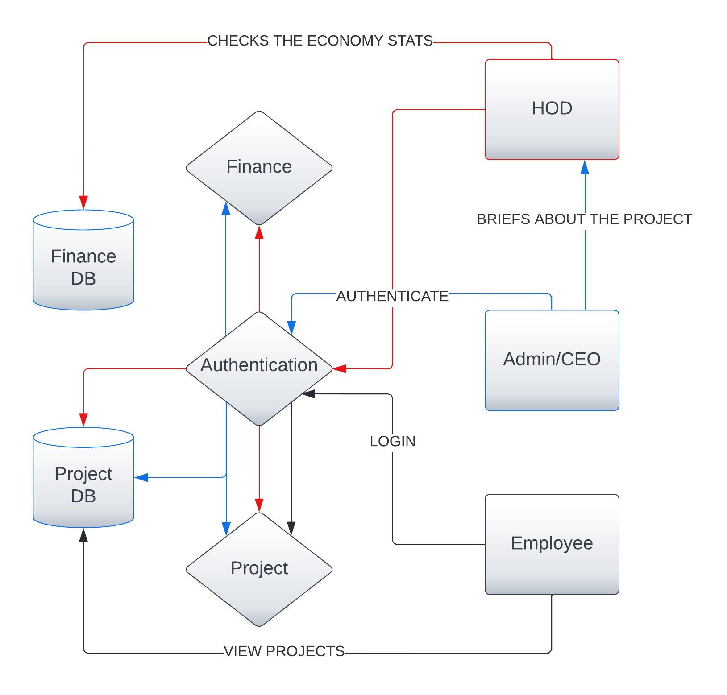

* + 1. **DFD Level 2**

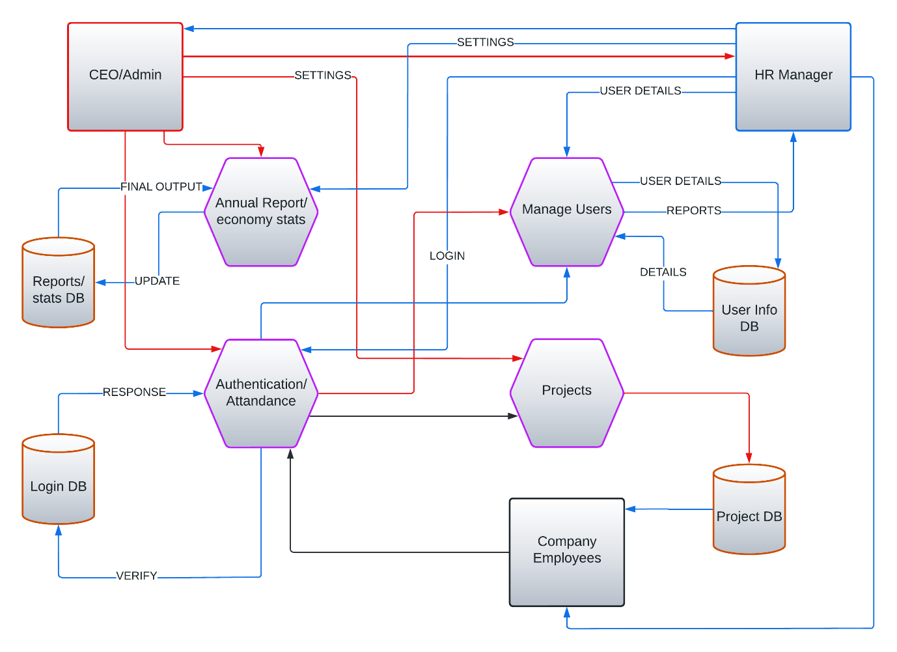

* 1. **Flow Diagram**

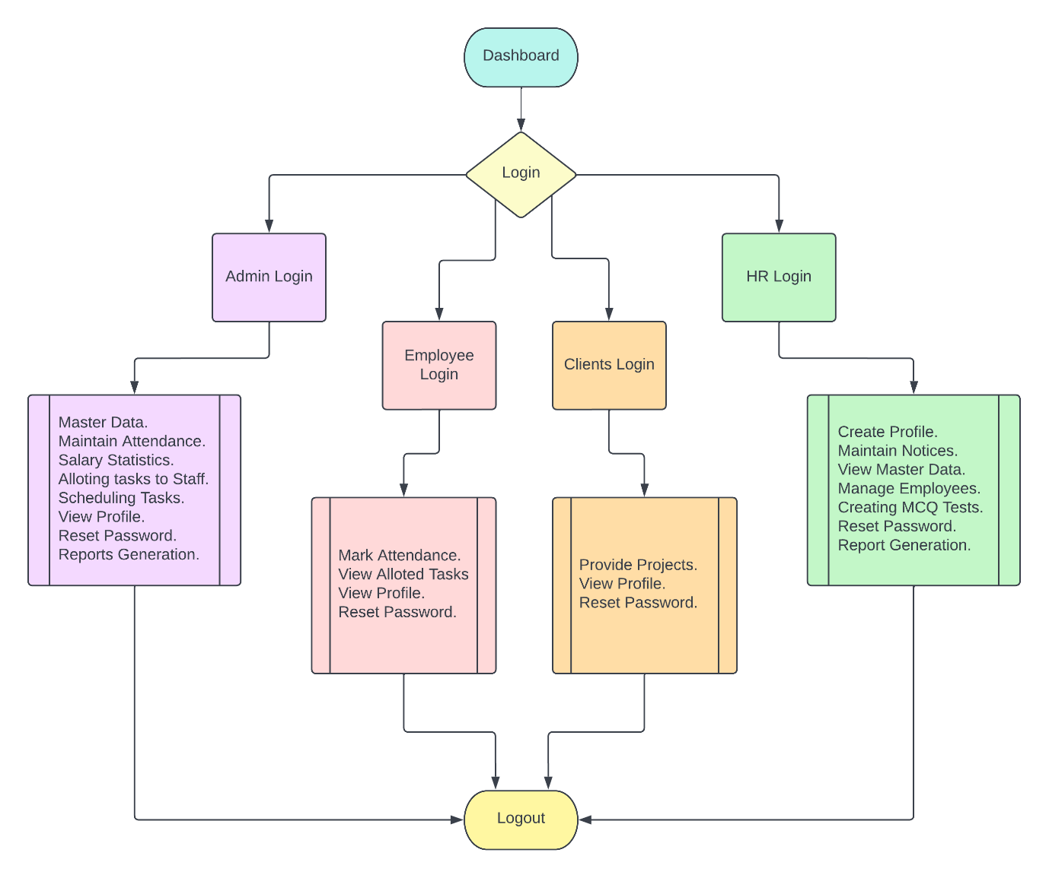

* 1. **Sequence Diagram**

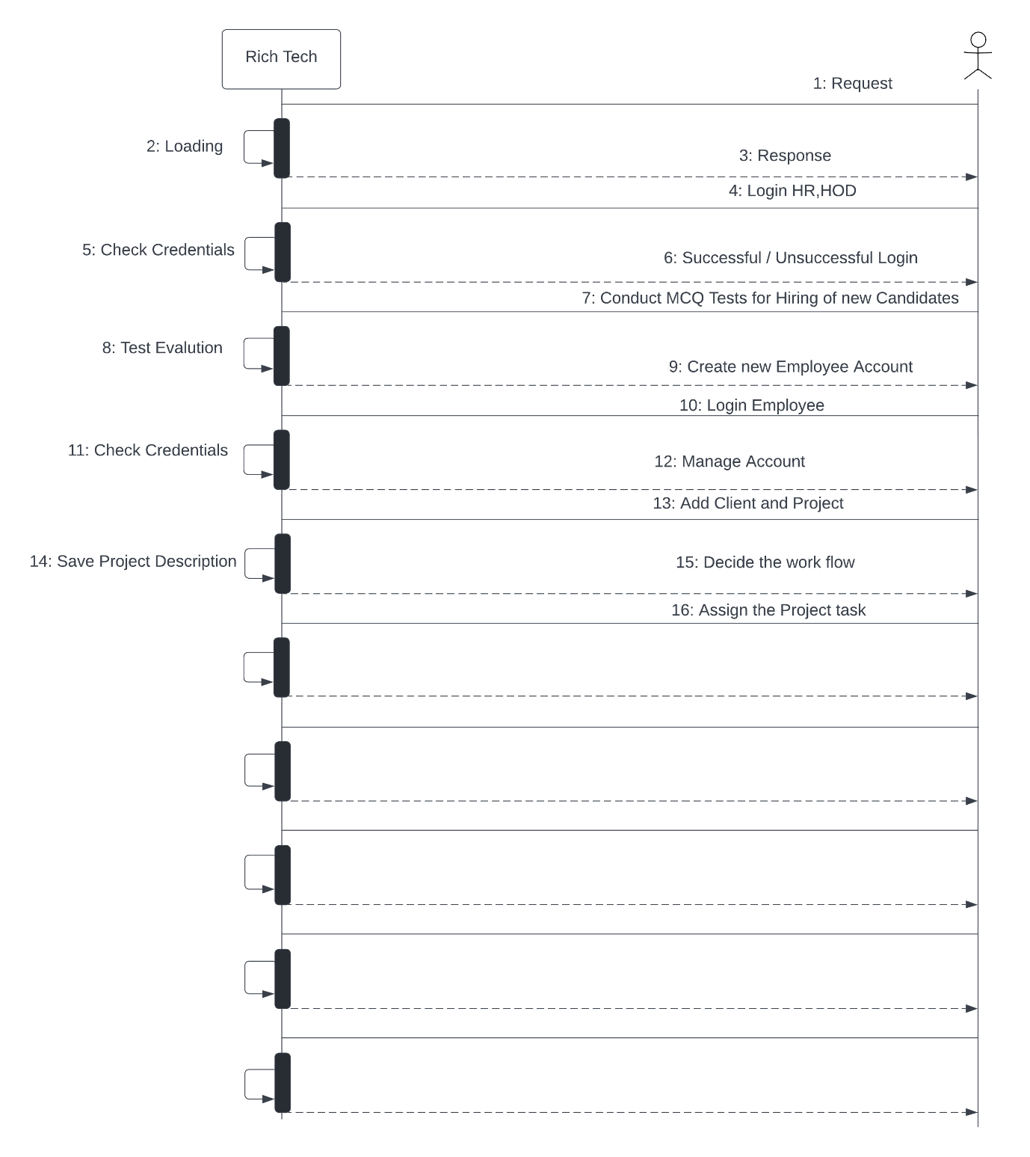

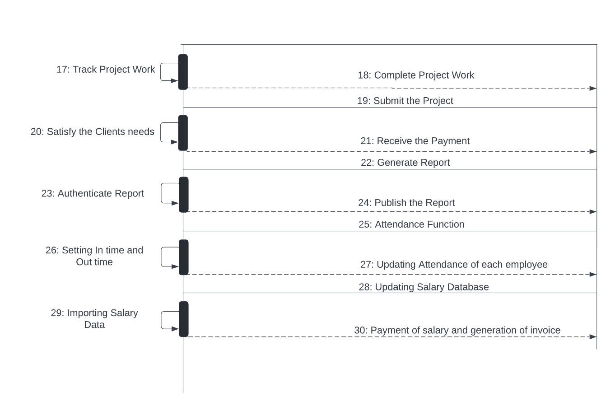

1. **Application Preview**

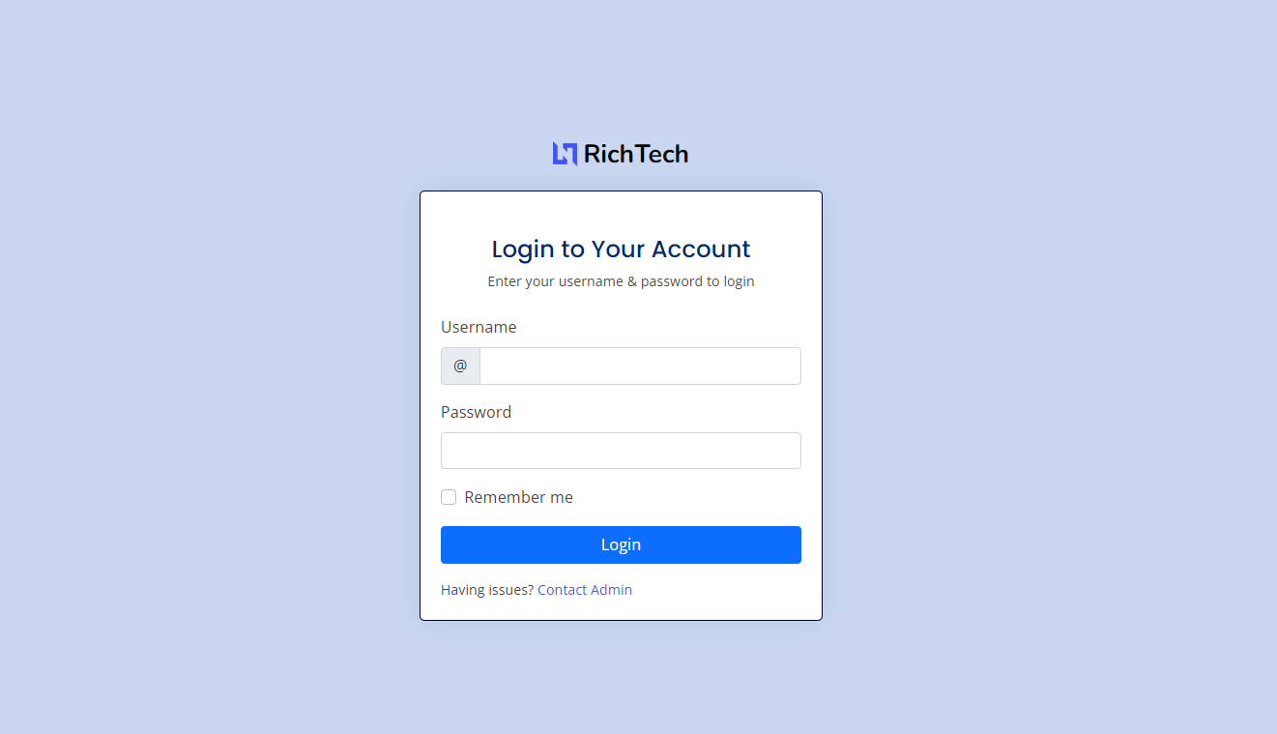

Fig 1: Login Screen

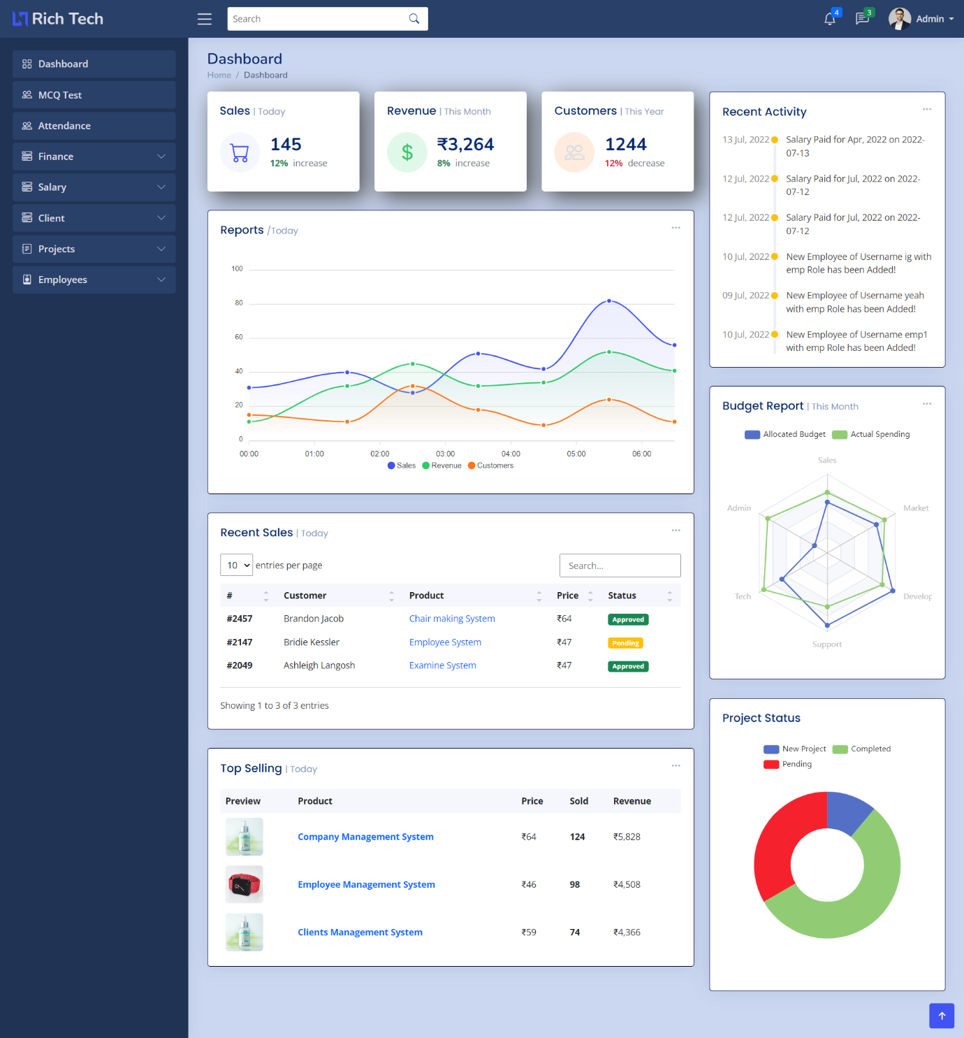

Fig 2: Admin Dashboard

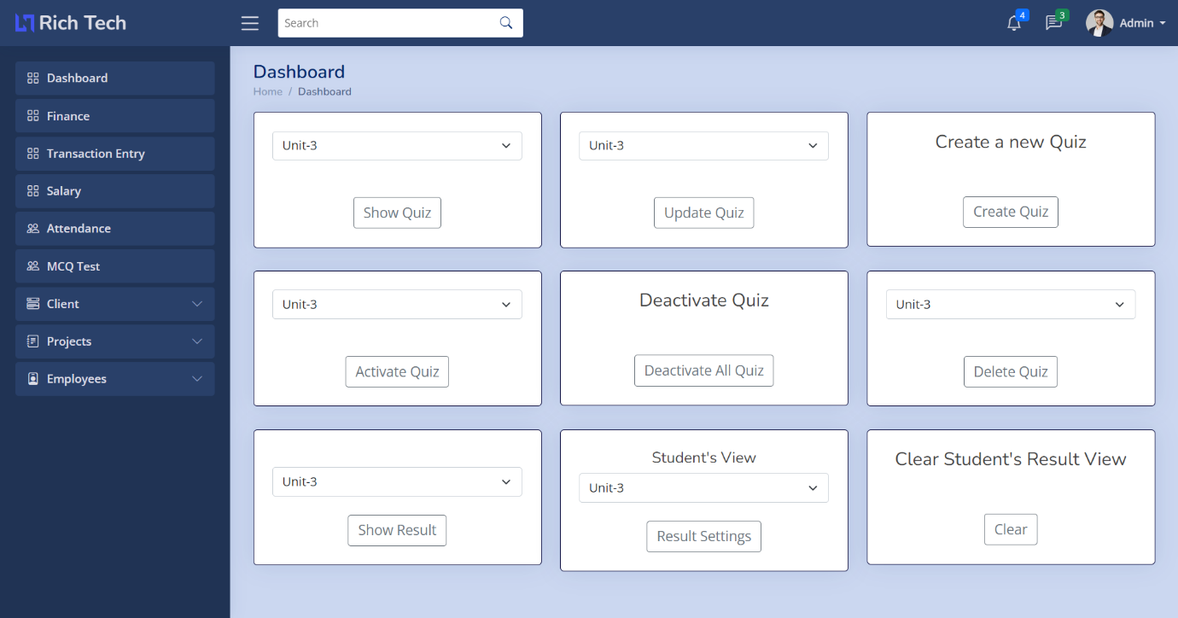

Fig 3: MCQ Dashboard

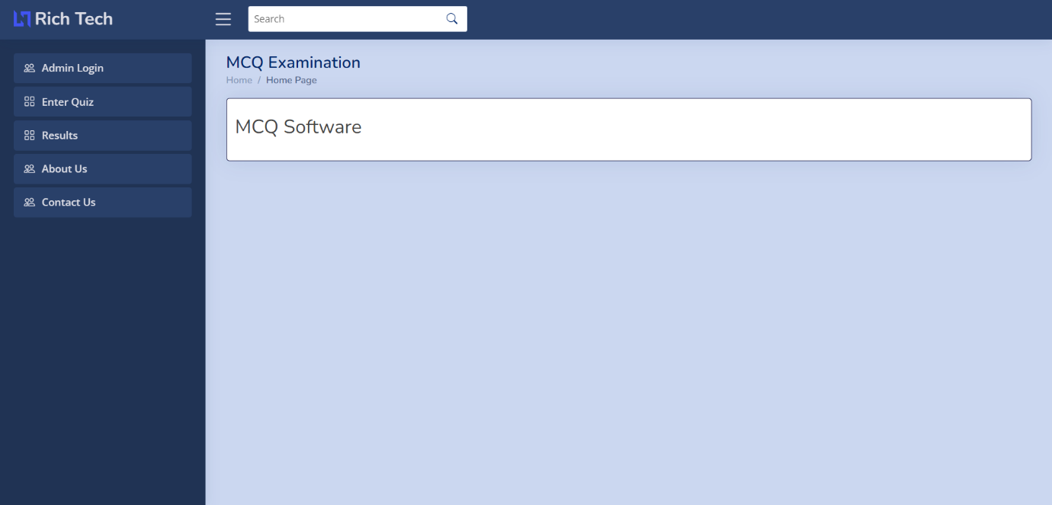

Fig 4: MCQ Dashboard – Candidate

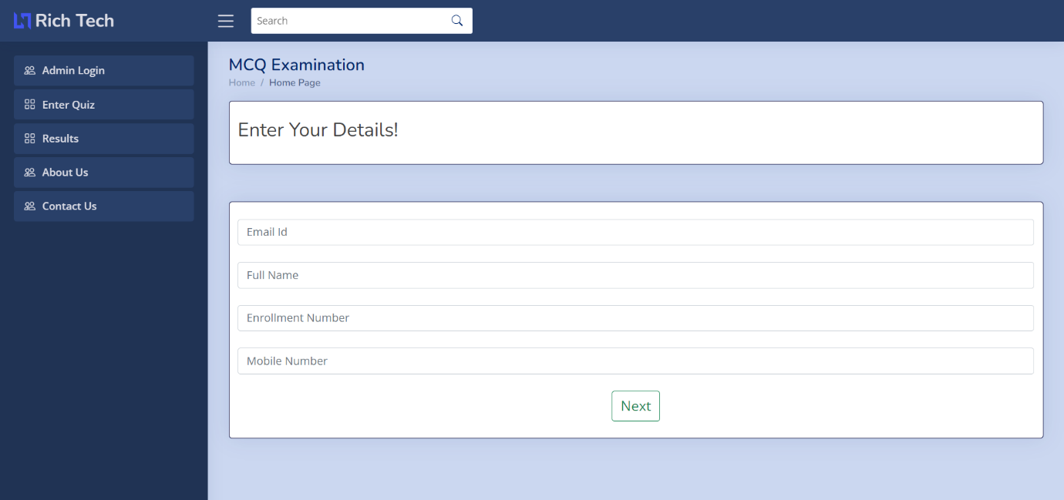

Fig 5: MCQ – Fill up form

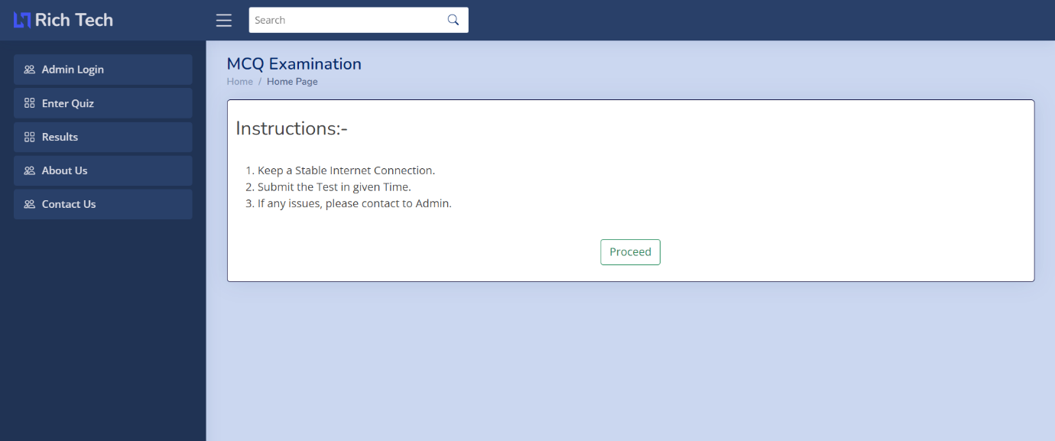

Fig 6: MCQ – Instructions

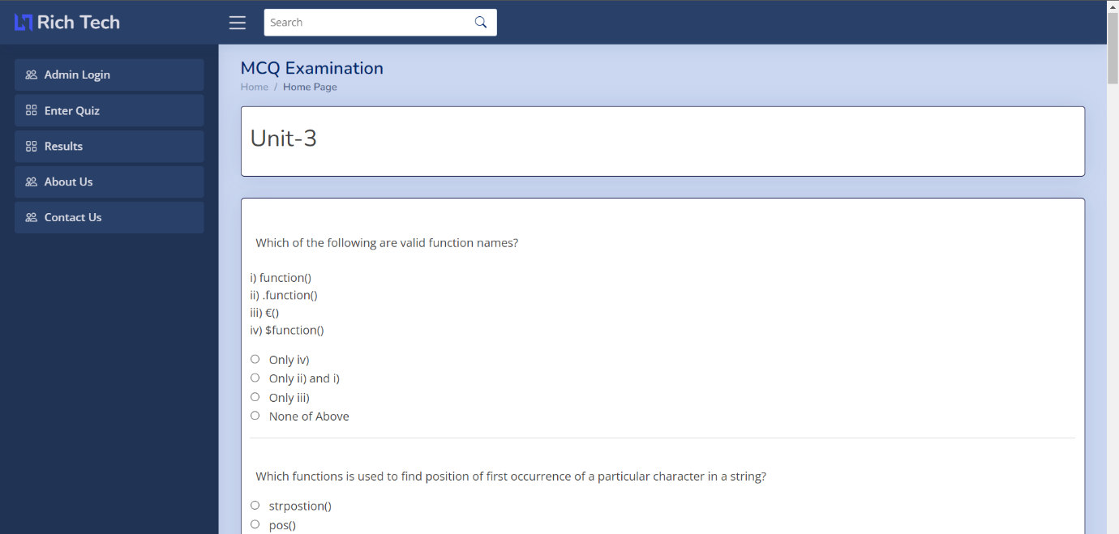

Fig 7: MCQ Examination Form

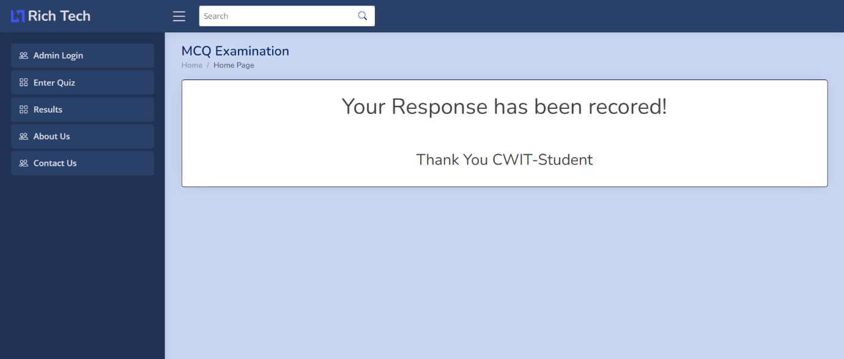

Fig 8: MCQ Submission

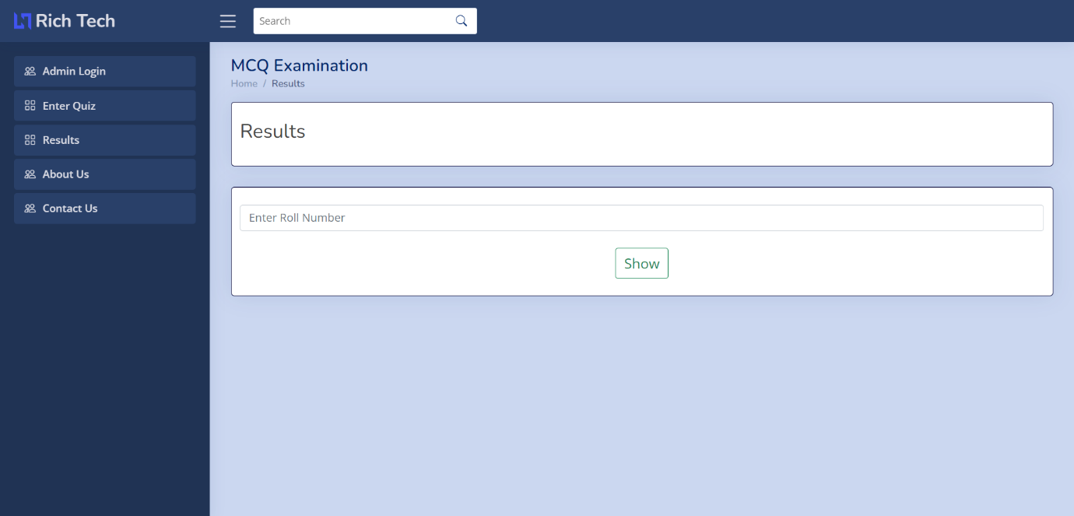

Fig 9: MCQ View Result Form

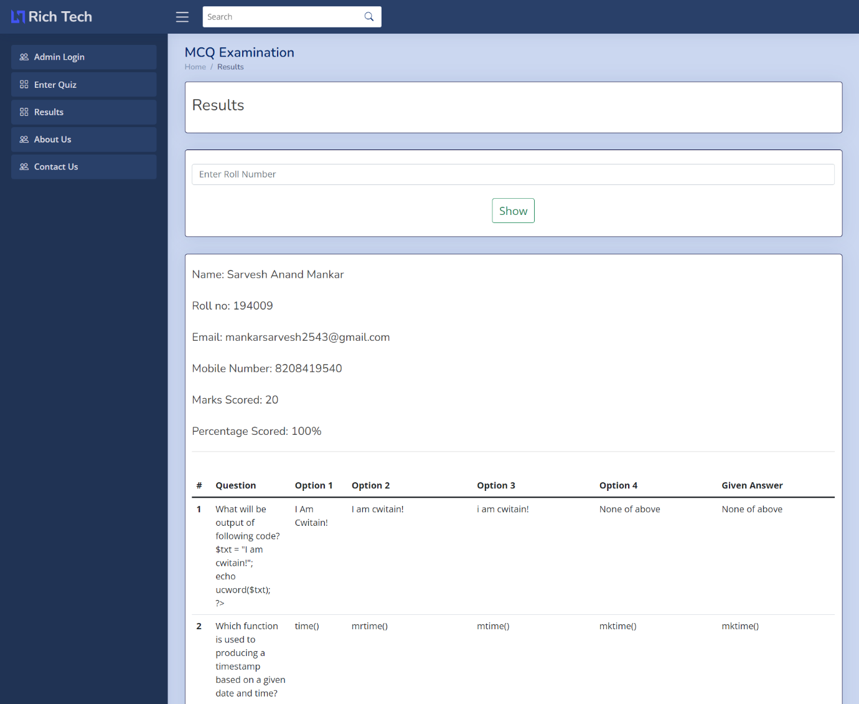

Fig 10: MCQ Results Page

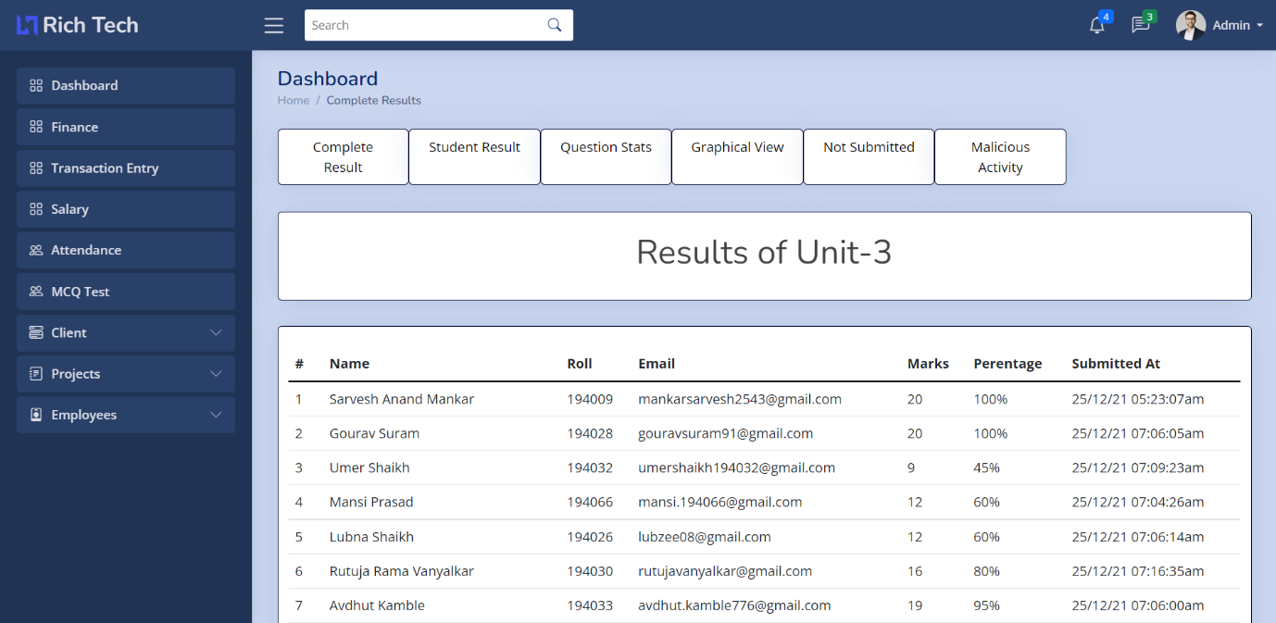

Fig 11: MCQ Result Stats

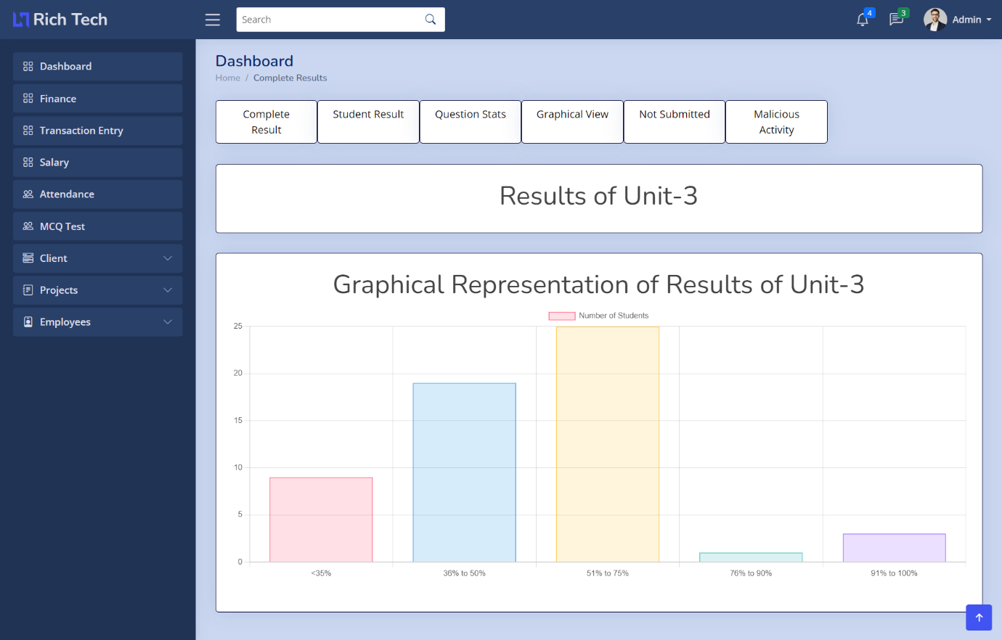

Fig 12: MCQ Graphical Representation of User Stats

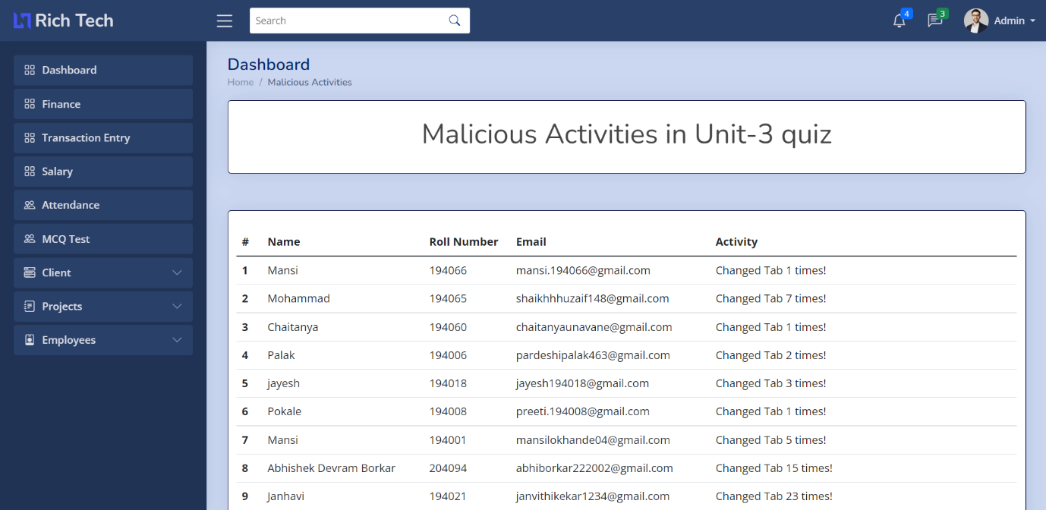

Fig 13: Malicious Activity Tracker

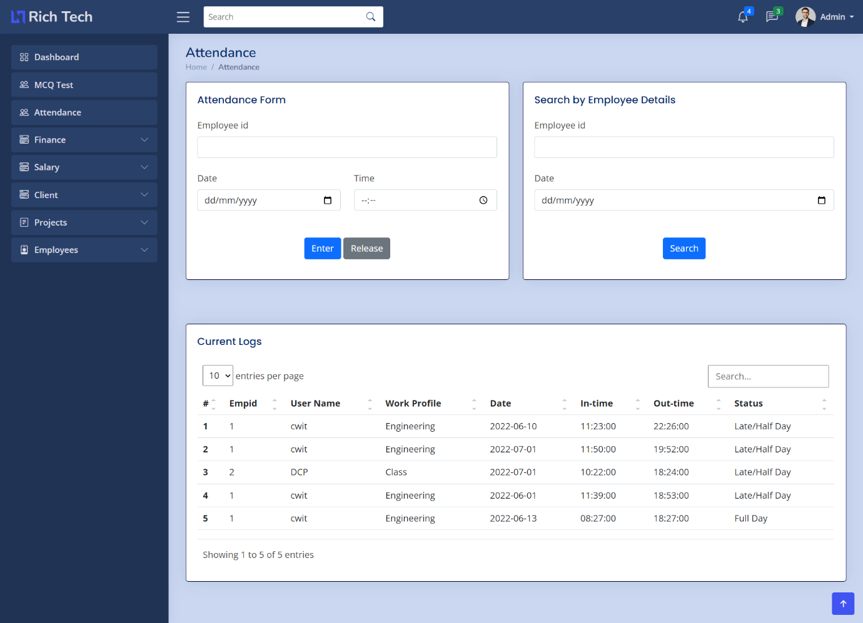

Fig 14: Attendance Form

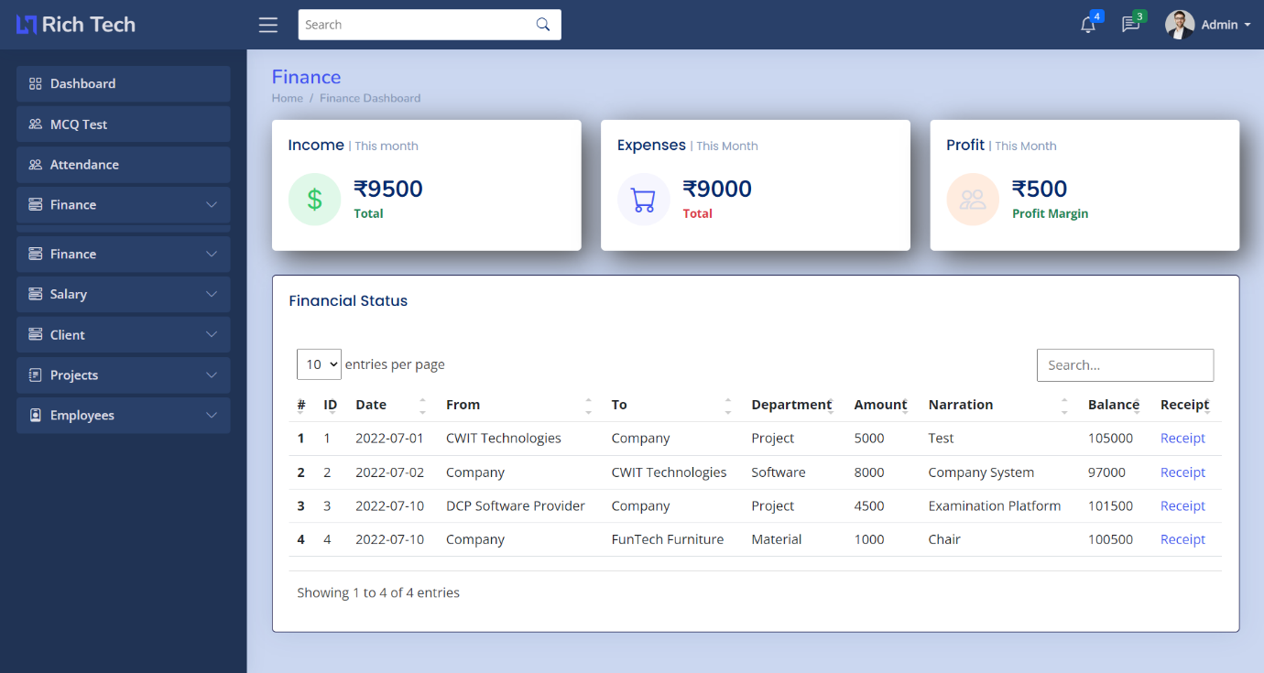

Fig 15: Finance Dashboard

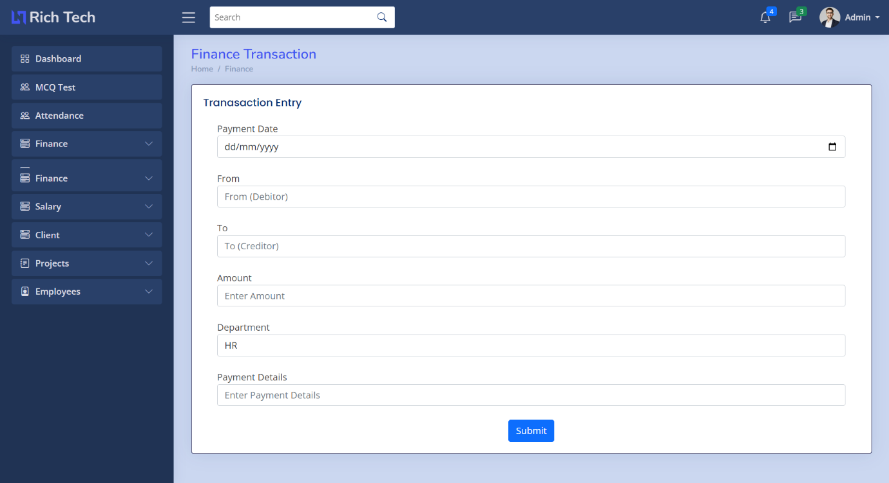

Fig 16: Finance- Transaction Entry

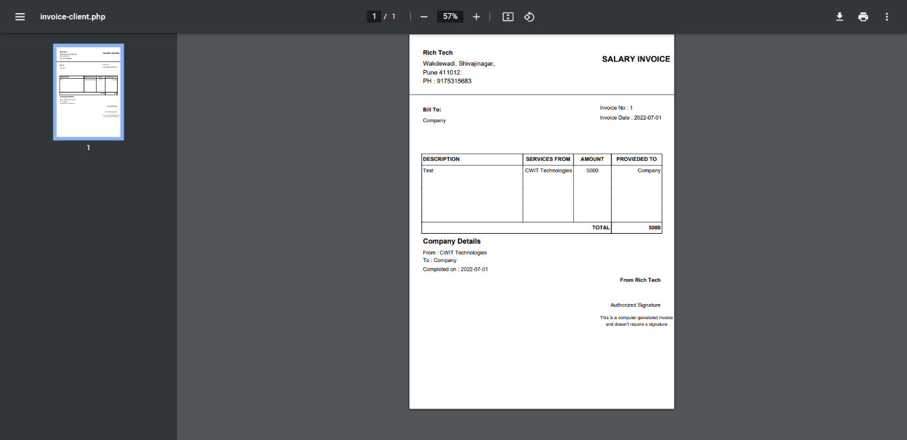

Fig 17: Finance Receipt

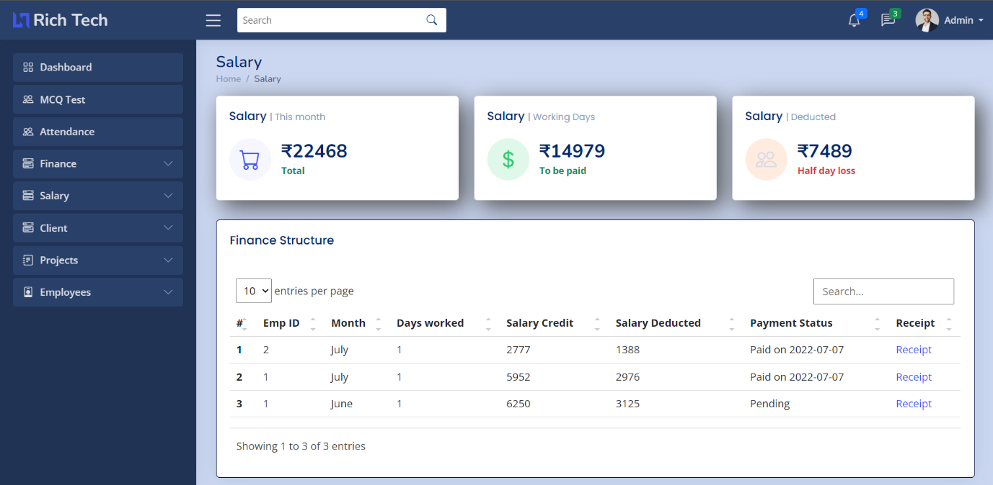

Fig 18: Salary Dashboard

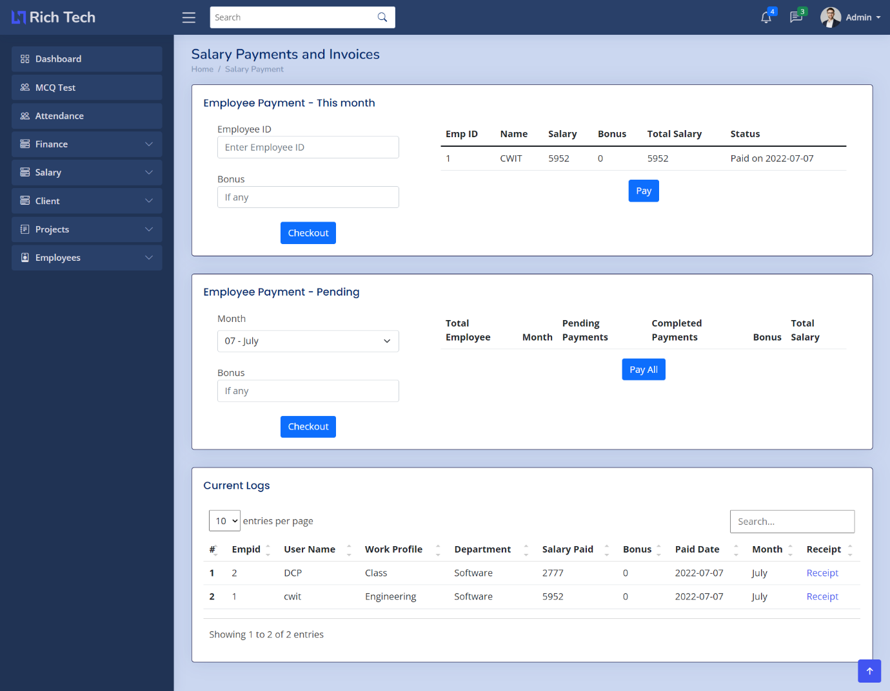

Fig 19: Salary Statistics

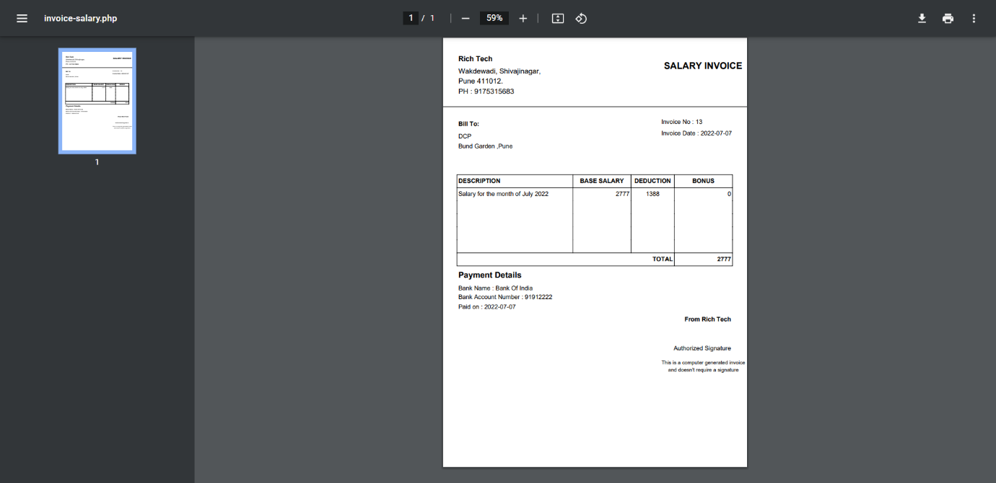

Fig 20: Salary Receipt

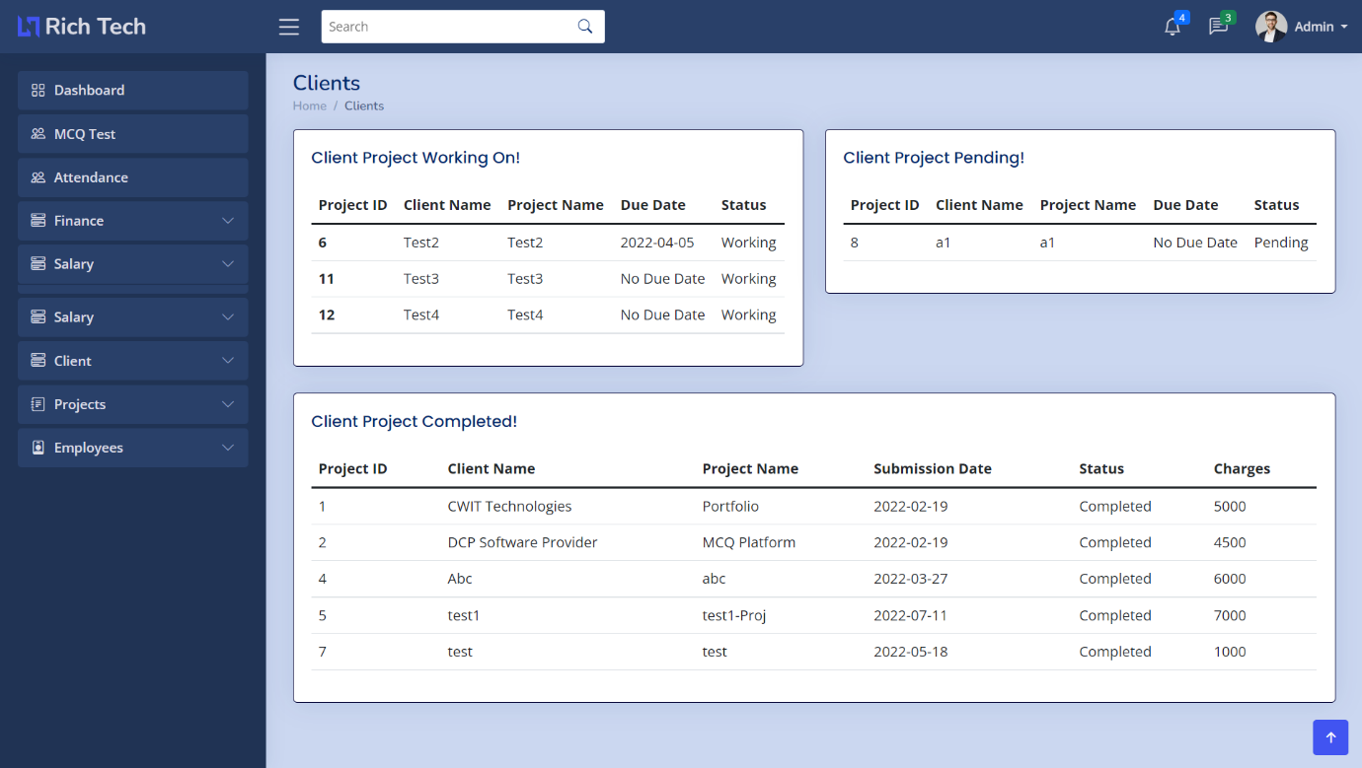

Fig 21: Client Dashboard

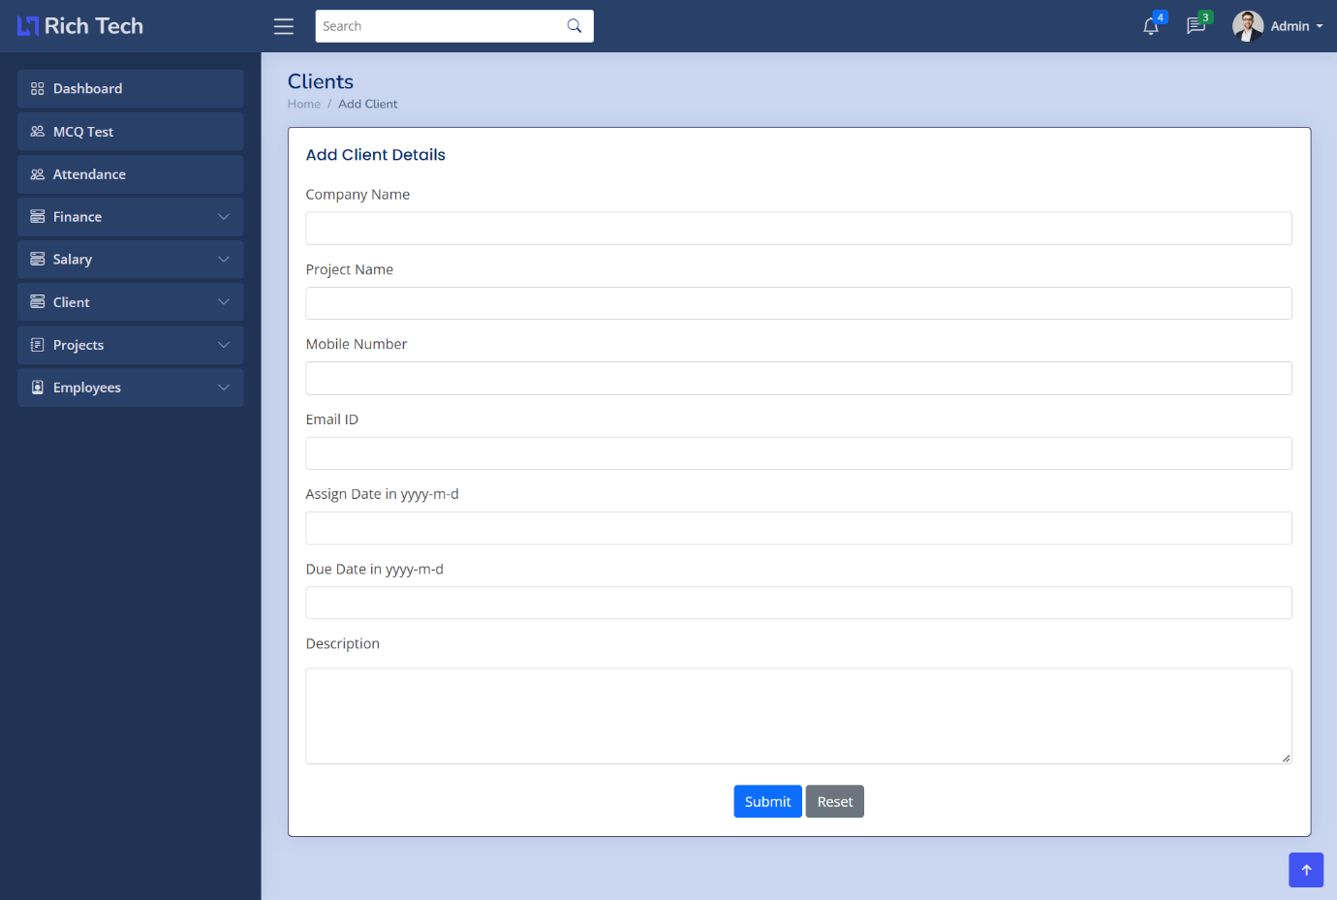

Fig 22: Add Client Section

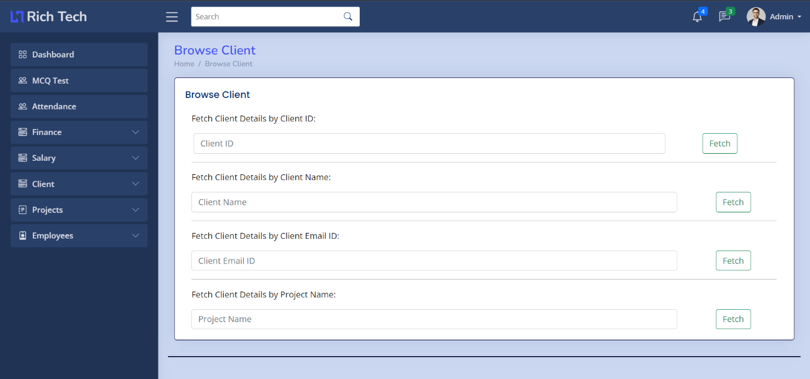

Fig 23: Browse Client

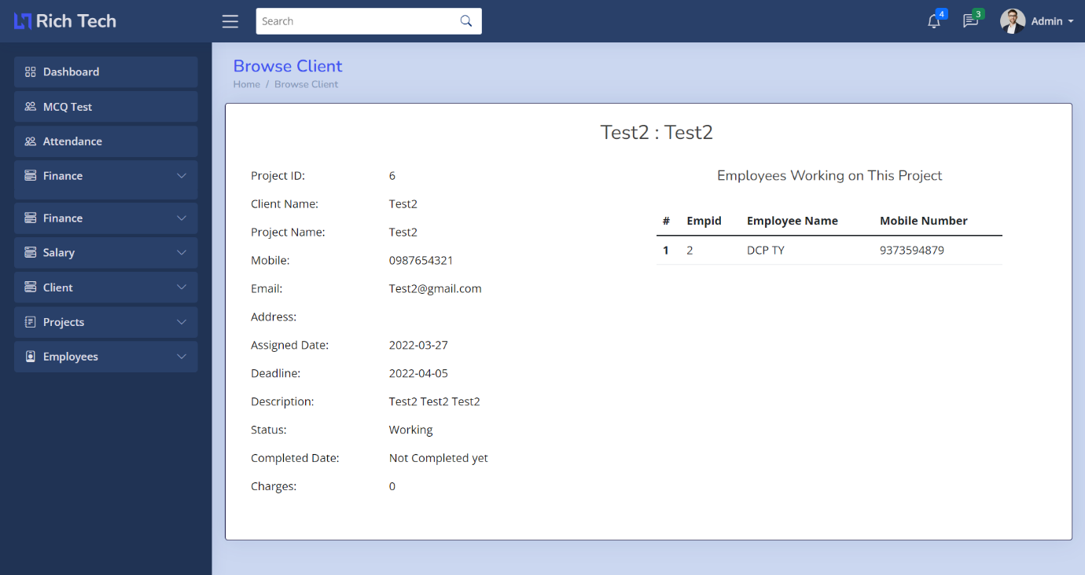

Fig 24: Browse Client by ID, Name, Email ID.

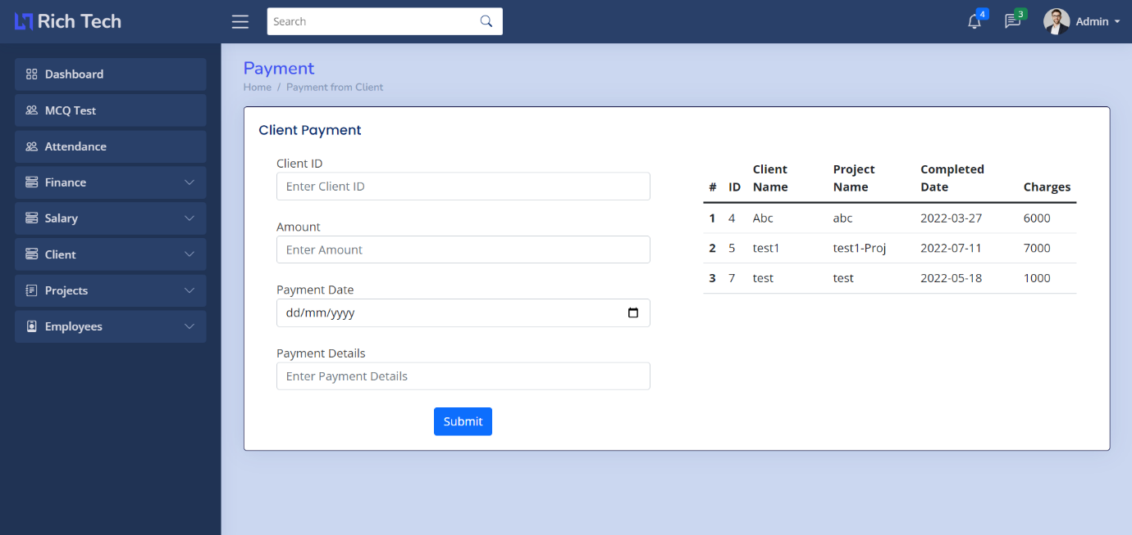

Fig 25: Client Payment

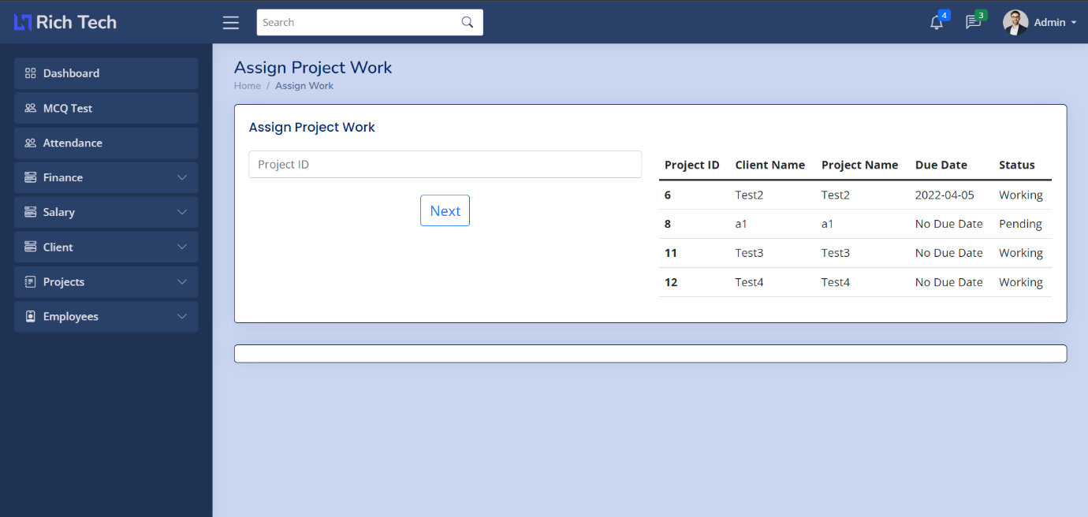

Fig 26: Assign Client Project to Employee

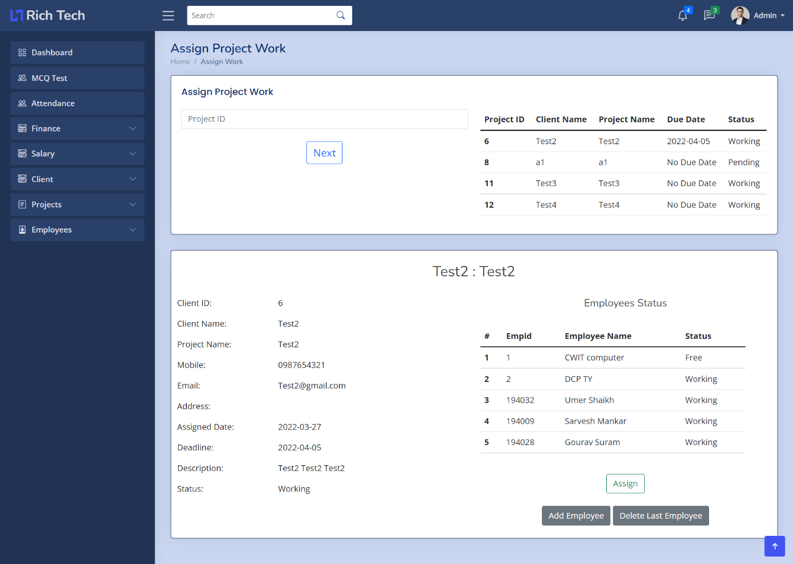

Fig 27: Project Status

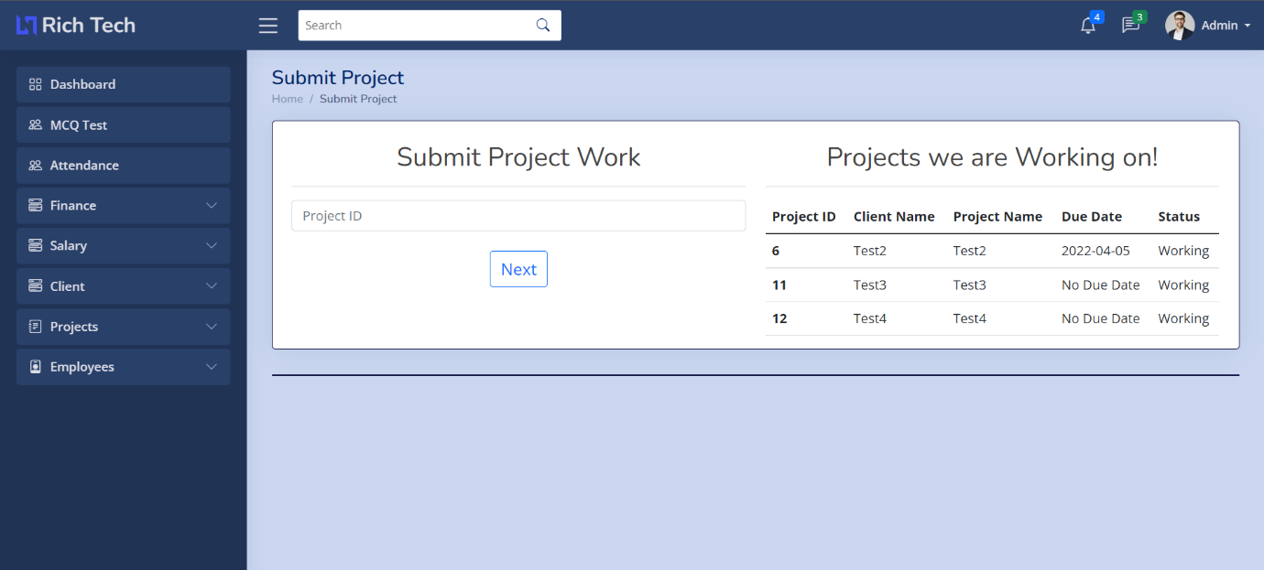

Fig 28: Update Project Status

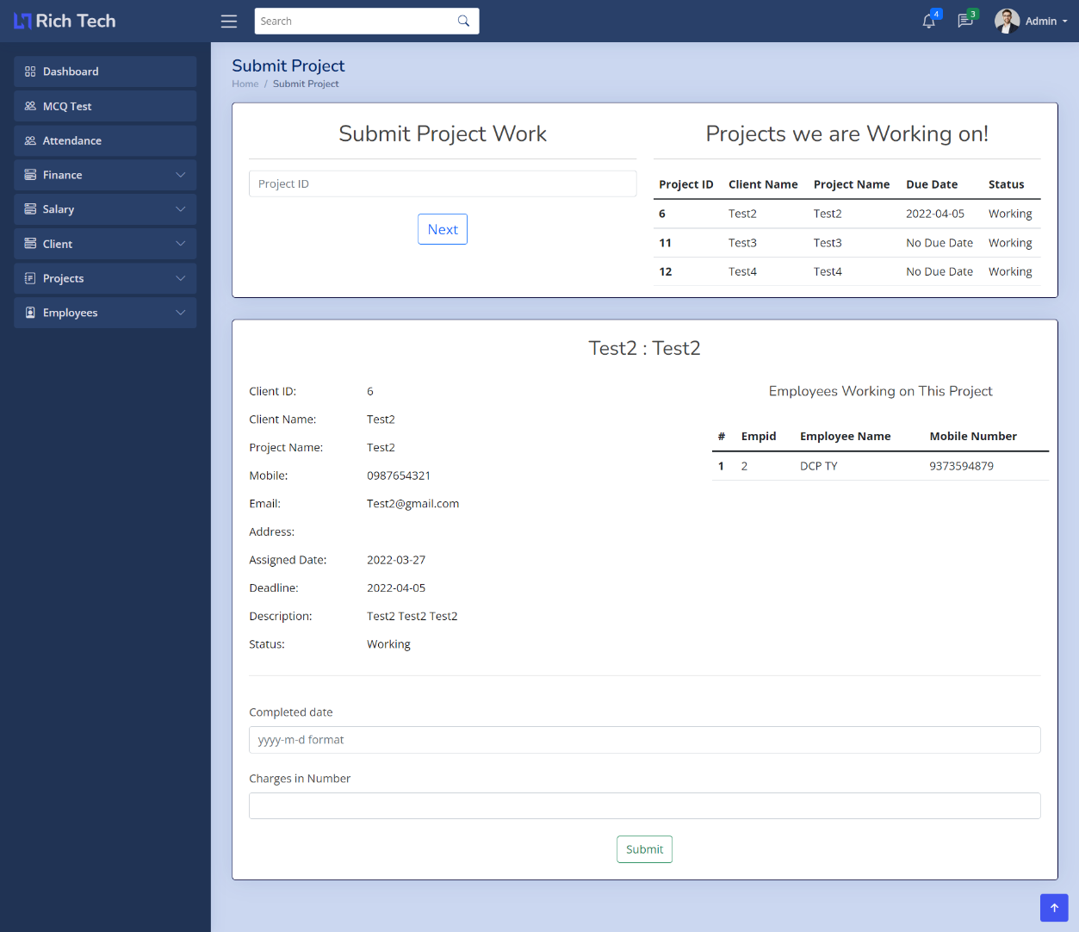

Fig 29: Check Employee Project Section

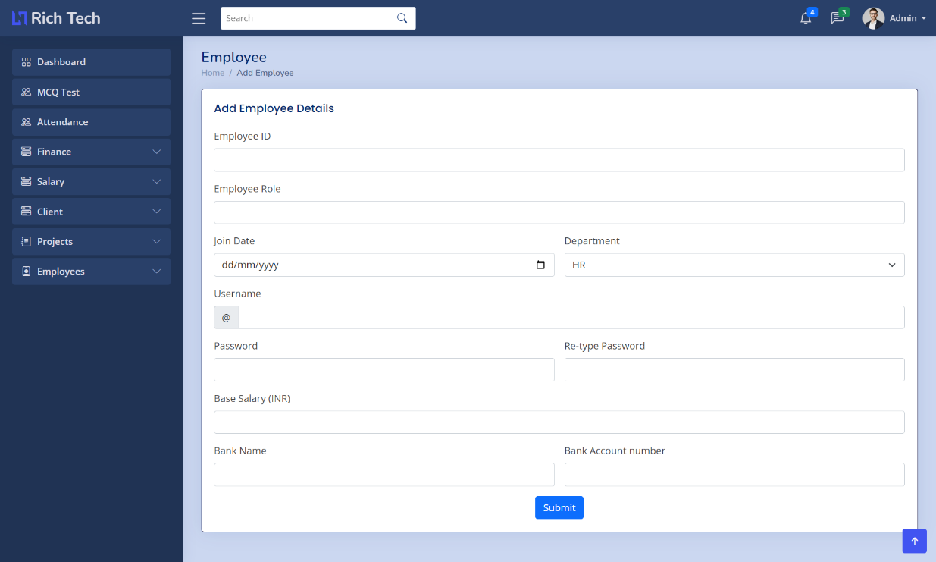

Fig 30: Add Employee Form

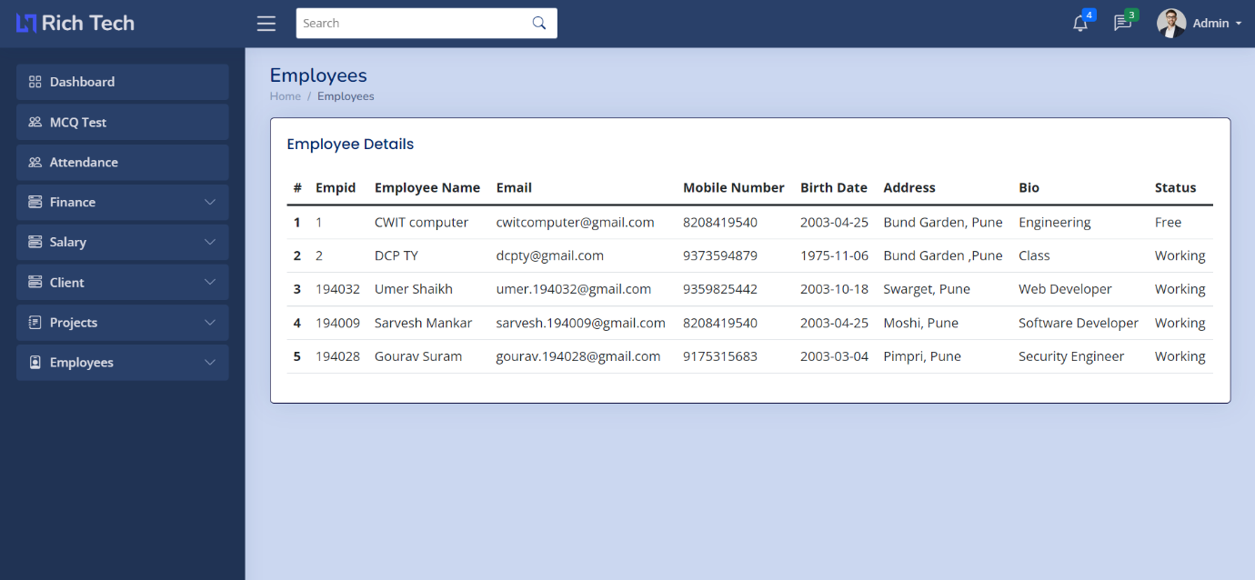

Fig 31: View Employee

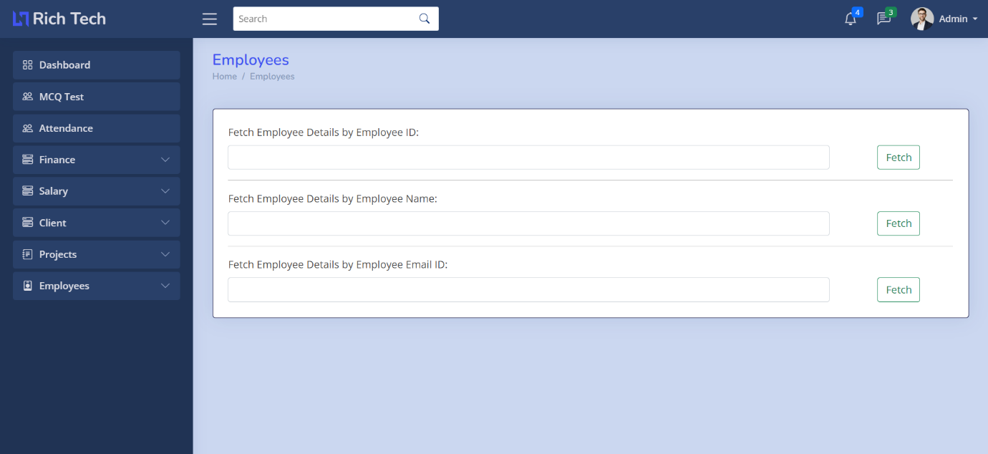

Fig 32: Search Employee By ID, Name, Email ID

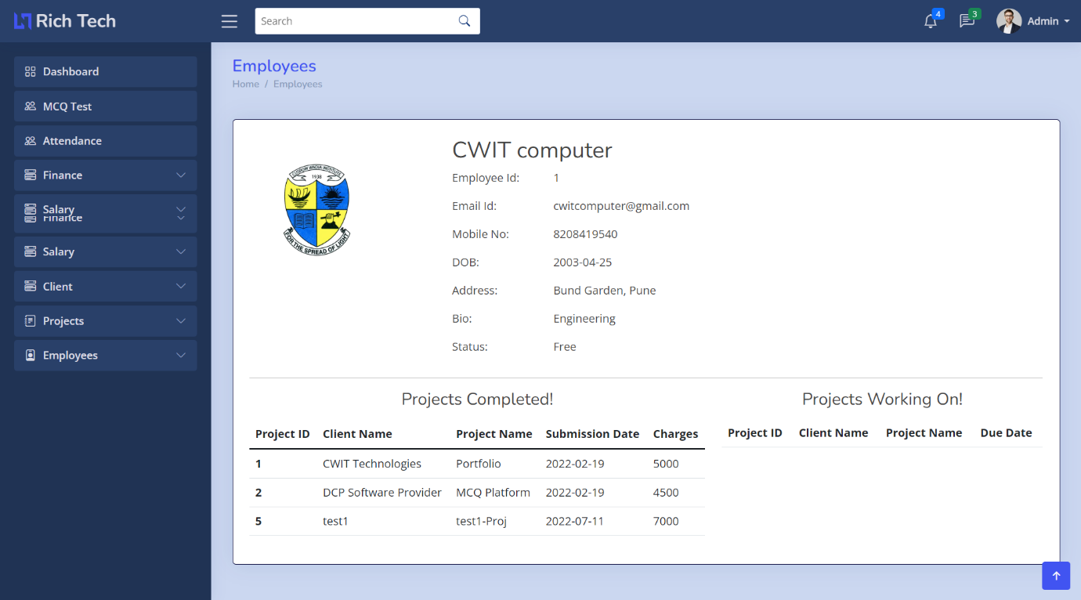

Fig 33: Employee Status

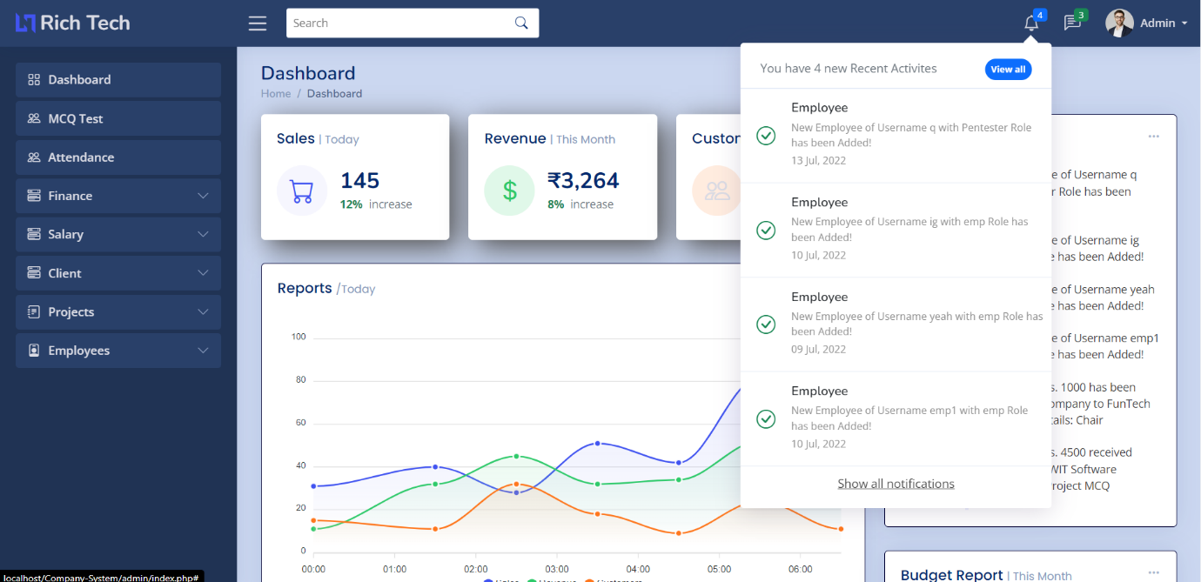

Fig 34: Notification Bar

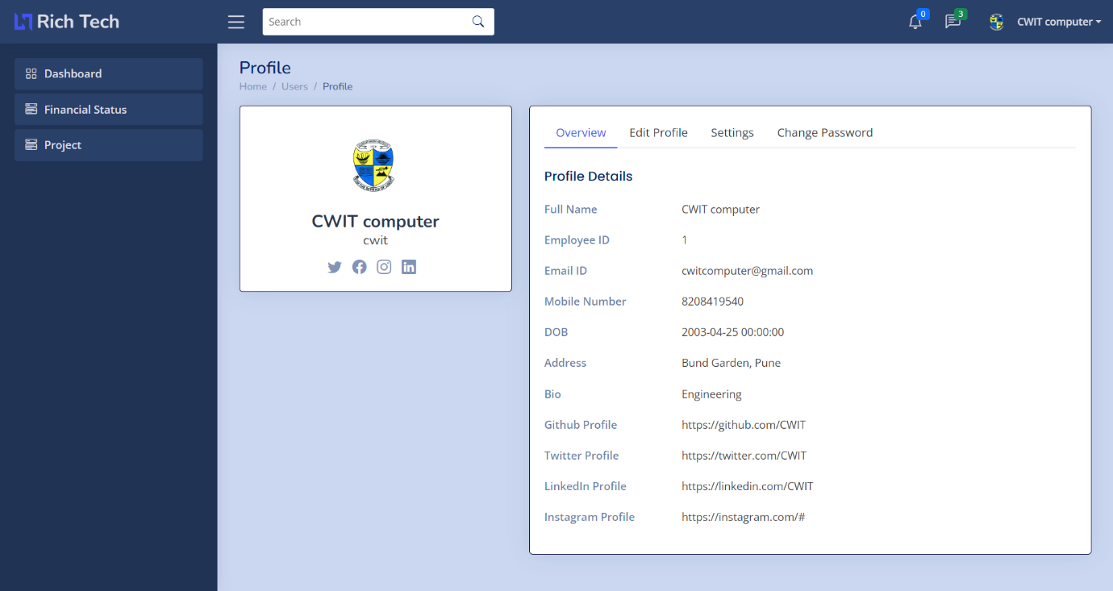

Fig 35: Employee Dashboard

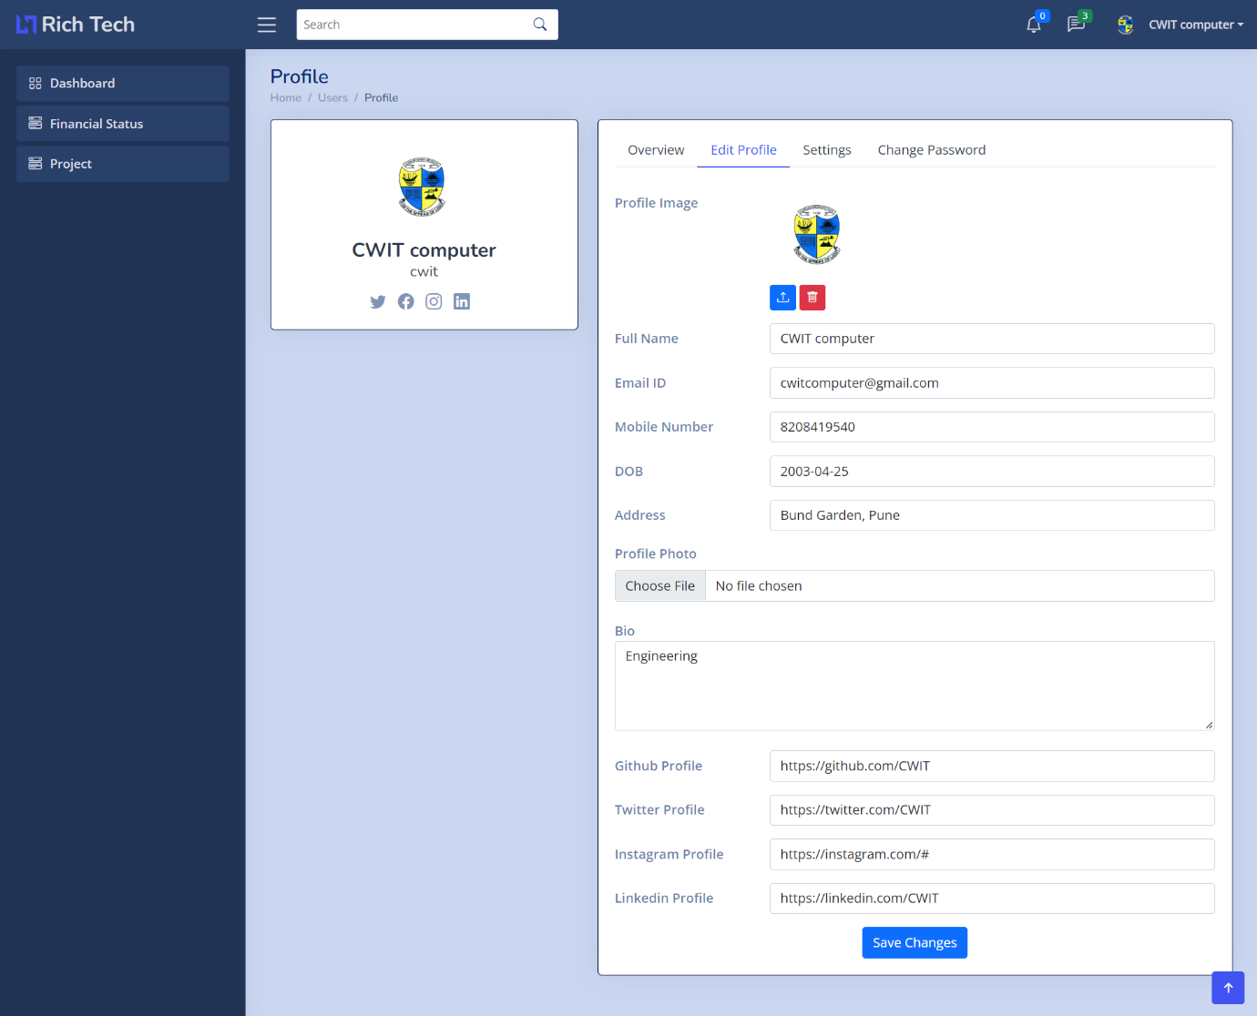

Fig 36: Edit Employee Data

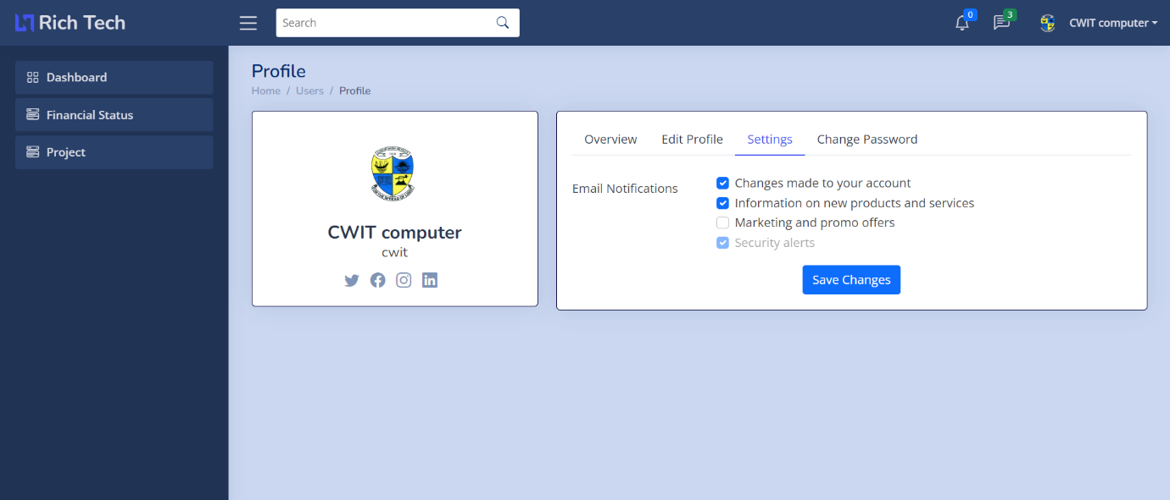

Fig 37: Settings Page

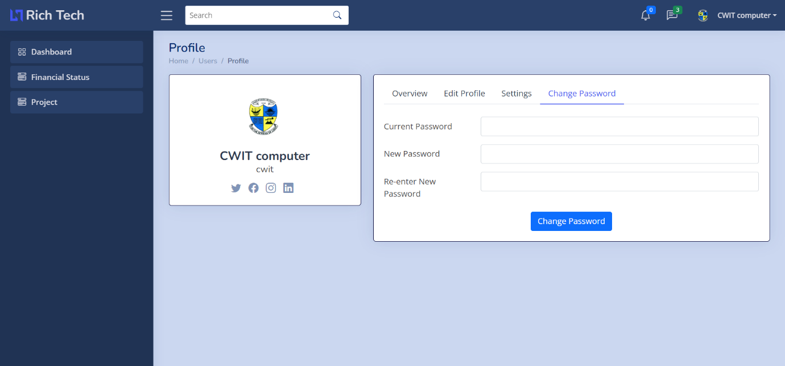

Fig 38: Change Password Form

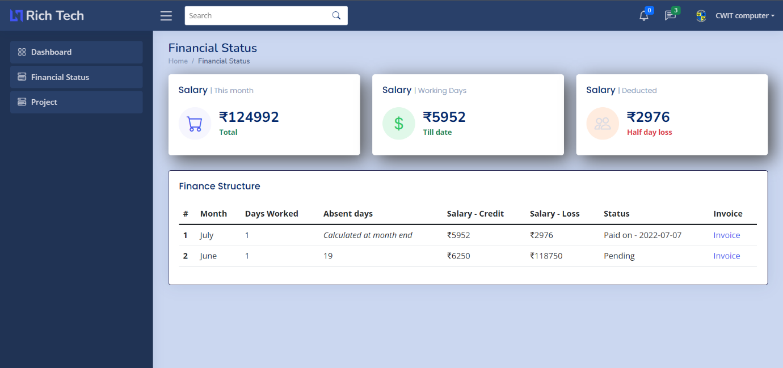

Fig 39: Finance Status – Employee

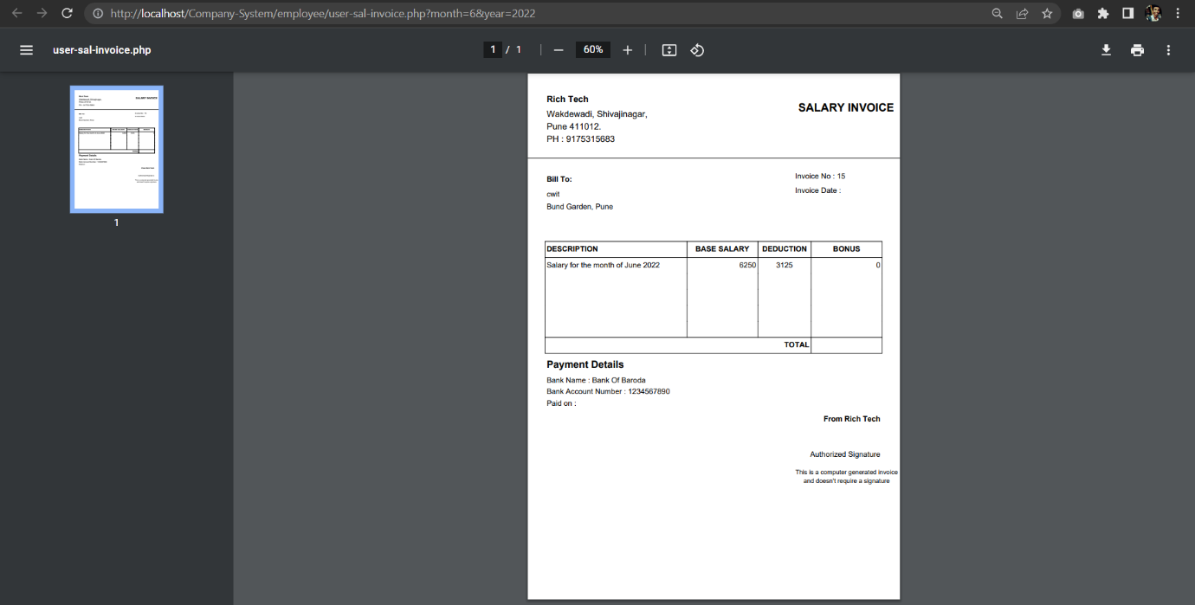

Fig 40: Employee Salary Receipt

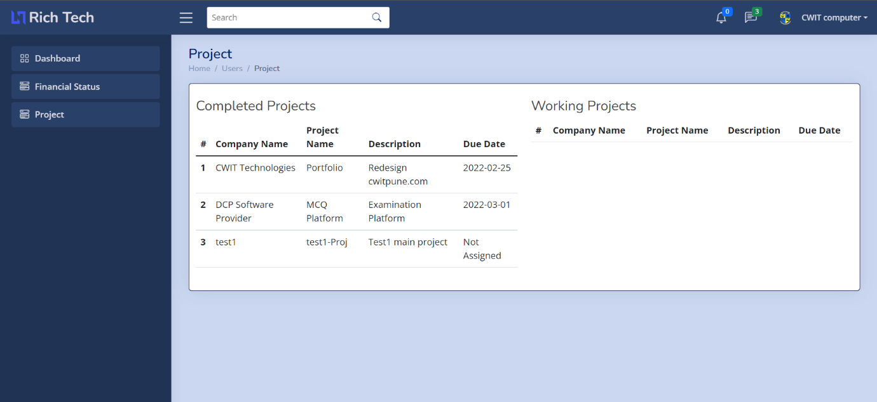

Fig 41: Project Dashboard

**11. Salient Features**

**1. Effective Management:**

**A high-quality software which manages each aspect of the company in a single workspace. It helps the High-Level Management to assign and keep track of the activities which are performed by the employees. Additionally, the application provides the feature to manage all kinds of reports likes Invoice, Receipts, Project Details, etc. into a single workspace. This makes them easy to manage and store.**

**2. Work evaluation:**

**The application provides the feature to assign the project task to multiple employees and keep track of their work. Their work can be evaluated and train the employees in order to improvise the project quality.**

**3. Leadership:**

One of the keys to a successful working and development Organization, and possibly the most important, is leadership buy-in from the top down.

Having leadership support helps to drive the importance of a program, assist with accountability and establish appropriate expectations. Leaders are provided with a better view towards the whole working order and helps to provide a better communication medium between different departments.

**4.Accessibility:** Allows you to access the parts of the system that you need regardless of time or place and, at the same time, prevents those with no access rights from entering; it simply matches access to responsibilities and ensures that the information stays secure.

**5. Avoiding errors:** With business management software, you only introduce the information once and the system will take care of the rest; this automation leaves no room for any error whatsoever.

**6. Collaboration:** Whether on-premise or remote, this application brings the team together with active collaboration features. We can also connect with different departments quickly. The Project reports are stored effective which provides a vital learning resource for freshers.

**7. Security:** The Company System works in a secured environment. The security is maintained by encrypting the password, specifying roles in hierarchical manner. The user input is sanitized which would not lead to any issues. The queries are programmed using prepared statement to pass exact data needed to avoid any kind of vulnerability in the software.

**12. Future Pro****spect**

Organizations have used management systems for a long time to help them create value and reach their objectives by actively managing risks and continually improving their performance. Such systems help companies manage a range of issues to do with quality, occupational health and safety, and the environment, as well as social and ethical concerns. But for management systems to continue to be a driving force for change, they must adapt.

In the Digital Transformation use of big data will become a key basis of competition and growth for individual firms. Organizations will leverage data-driven strategies to innovate, compete and capture value from deep, real-time information. However, there is also the issue of rising security and privacy threats. As analytics and social media reach every aspect of an organization, safeguarding data will continue to be a major concern for individuals and organizations.

The key feature of Company System is to manage and process the data in an effective manner which results the outcome to be the best.

The Software is built with the use of Open-Source languages and utilities such as PHP, JS, jQuery, which have the potential to adapt themselves with the changing technologies. Flexibility, Scalability, Robustness are some of the key features of Company Management System.

**13. References**

<https://archdesk.com/blog/benefits-of-a-business-management-system/>

<https://www.proofhub.com/articles/best-business-management-software>

<https://www.getanp.com/blog/59/top-12-features-for-work-management-software-that-matter-most.php>

<https://www.scoro.com/blog/best-business-management-software/>

https://managementhelp.org/training/

https://www.ej4.com/blog/guide-to-creating-employee-training-and development-program

https://www.qualitymag.com/articles/94207-the-future-of-management-systems